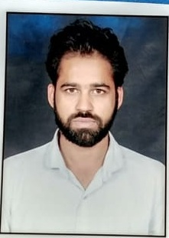
SANDEEP KUMAR
Village-Dohana Khera
Teh-Narwana Distt-Jind (Haryana) 126116 Contact No- 8930973554
Email –sandeepdoctor888@gmail.com

OBJECTIVE

- Objectives are meant not to be talk about but to achieve them.
- Real efforts can truly realize the potentiality of human soul.

EDUCATIONAL QUALIFICATIONS
- MSc(pure-Mathematics) from Kurukshetra University, Kurukshetra in 2014.
- B.SC(non- medical) from Kurukshetra University, Kurukshetra in 2011.
- 12th (non—medical)from HBSE in 2007.
- 10th from HBSE in 2005.

PROFESSIONAL EXPERIENCE
- Eight Year experience as Assistant Professor in Mathematics in Rajiv Gandhi Mahavidyalya,Uchana(126115) (from 2015 to june 2022)
- One year experience of solving of PROBLEMS OF MATHEMATICS OF THE LEVEL OF IIT—JEE,JEE(ADVANCED)
- Tow year experience of solving of problem of(NET,GATE LIKE) EXAM.
- EXTRA ACHIEVEMENTS
- CSIR NET Qualified -2018 (All India Rank-11 )

STRENGTHS
- Belief in my abilities
- Confidence of achieve deadline in stipulated time.
- To be one with the object.
- Motivational skills.
PERSONAL DETAILS
Date of Birth | : | 30.09.1988
Marital Status | : | Unmarried
Gender | : | Male
Nationality | : | Indian
Languages | : | English, Hindi
Date.11/07/2022
Place. Narwana |  | (SANDEEP KUMAR)

