Ashutosh Pathak
Mob:7869502698
8770628092 Email:pathak.ashutosh110@gmail.com
Address: 104 Choudhary Colony Mandsaur Madhya Pradesh
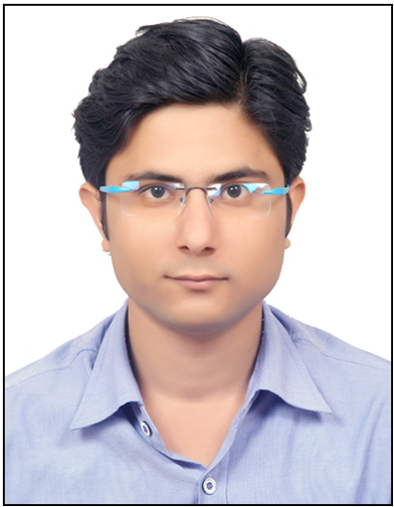
My aim is to work innovatively for the enhancement and betterment of education. I aspire to work for an institution which offers career growth and chances to learn and improve my knowledge.

Profile Snapshot:

- A career focused in individual, with B.E.(ME) from Rajiv Gandhi Vishvavidyalaya.
- Conceptually and numerically strong in relevant subject.
- Strong communication skills.
- Problem solving expertise
- Excellent bonding and connection with students.

Experience:
5 years of experience in teaching (Physics)
Aakash Institute Udaipur
Catalyser Institute Surat
EG Tutotials Mandsaur
Education:
Std | Board/University | Percentage | Division
B.E. | RGPV | 76.2 | 1st
12th | MPBOARD | 82.4 | 1st
10th | MPBOARD | 91.2 | 1st

Teaching Abilities:
- Able to conduct classes in a disciplined environment where children are challenged.
- Able to provide high quality learning experiences for students.
- Friendly personality and excellent verbal written communication skills.
- Excellent class management skills.

Personal Details:
DOB: 10thAugust 1993
Languages: English, Hindi

