**Abhilash Sharma**

* 🕾 +918770540163  
   abhi.rated001@gmail.com   
   L-5 Jawahar Nagar  
   Ratlam (M.P.) -457001



Objective

Seeking a dynamic position as an Engineer in a reputed company which will utilize my technical knowledge and skills.

Educational Qualification



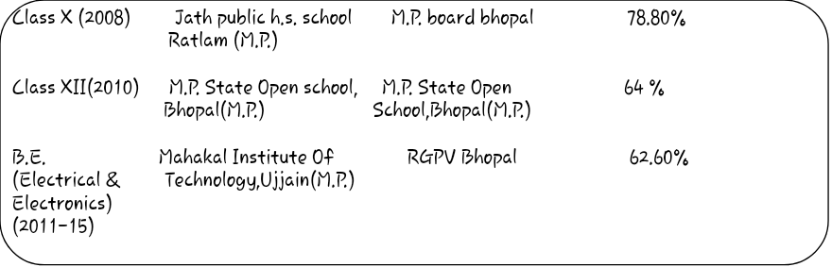

Technical Skills

    

* C/C+ +
* Ladder programing
* MATlab with Image processing and Acquisition,
* Embedded System
* PLC (Allen Bradly and Simens)
* SCADA (Intouch)

INDUSTRIAL TRAINING

* Industrial Training of PLC & SCADA taken from Prolific Systems and Technologies Pvt. Ltd. Mumbai

Activities  
   
 🢧Enjoy working in a multi-cultural placed and simulating environment.  
 🢧Flexible & adaptive to change, resourceful in getting the job done.  
 🢧A team member with strong interpersonal and analytical skills.  
 🢧Good Communication skills.

PROJECTS

**Minor Project-**

Designing Of Circuit Of Controlling Fan’s Speed By Temprature Sensor(LM35)

**Major Project-**

Automatic Side stand Remover

Intrests and hobbies

* Singing, watching movies, swimmimg etc.

Work Experience

Having 4 year teaching experience of General awareness and Quantitive aptitude at home and coaching centres.

Personal information

Name: Abhilash Sharma

Father's Name: Arun Kumar Sharma

Father’s Occupation: Retired employee   
Mother’s Name : Antim Sharma

Nationality: Indian

Languages: English, Hindi,

Marital Status: Single

I hereby declare that the above mentioned information is correct up to my knowledge and I bear the responsibility for the correctness of the above mentioned particulars.

Place - Ratlam Signature-

Abhilash Sharma