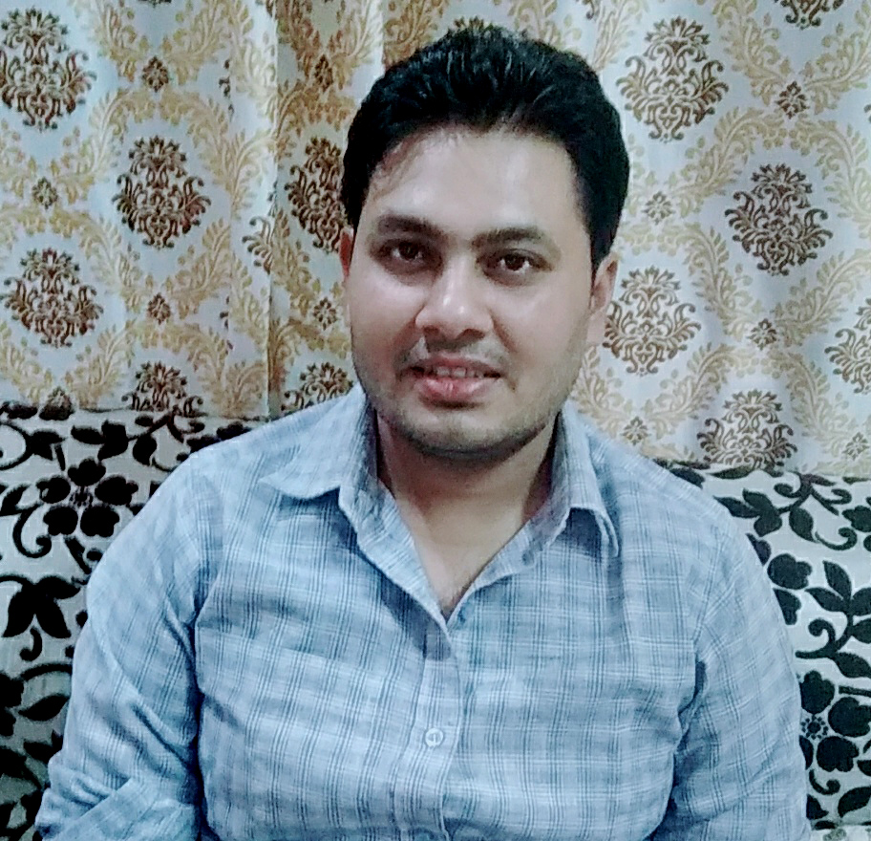 |  |  |  | Anshul Kumar Nayak  S/O Sri Arvindra Nayak

Experience
4 years experience from 2016 to till now in MAHENDRA EDUCATION PRIVATE LIMTED BKD ROAD NEAR KUNJVIHARI COLONY JHANSI UP

POSTED FOR SUBJECTS
HISTORY•GEOGRAPHY•POLITY •SCIENCE • ENVIRONMENT

Education
- HIGH SCHOOL IN UTTAR PRADESH BOARD ALLAHABAD

- INTERMEDIATE IN UTTAR PRADESH BOARD ALLAHABAD

- B. TECH WITH COMPUTER SCIENCE

- advance study subjects History/ Polity/ Geography/ Science/ Environment

Communication
Able to communicate effectively with a wide range of people, by showing interest and carefully listening to their needs.

Leadership
Guided my team members for adopting a new work strategy which helped meet the organizational goals and targets.

Language Proficiency:
Read, write and converse fluently in English and Hindi.
VILL POST SINDWAHA BLOCK MEHOUNI
TEH PALI DISS LALITPUR UTTAR PRADESH
PIN- 284405
+91-9456632356
+91-7007488046
 |  | Anshulkumarnayak88@gmail.com

