EDUCATION

Master of Arts
Dr. B.R. Ambedkar University Of Social Science
2023 - Present MHOW [INDORE]

SKILLS

Hardworking
Passinate
Effective communication

Bachelor Of Arts
Reformer
Devi Ahilya University , Indore
2020 - 2022 INDORE

Advance Diploma In Computer Application [ADCA]
Rajeev Gandhi Computer Saksharta Mission
2020 - 2021 i

High Secondry School Examination
Meher Public High Secondry School
2018 - 2019 Indore

High School Certificate Examination
Meher Public High Secondry School
2016 - 2017 indore

LANGUAGES

English
Full Professional Proficiency

INTERESTS
Reading books

Badminton

Hindi
Full Professional Proficiency

collect old coins

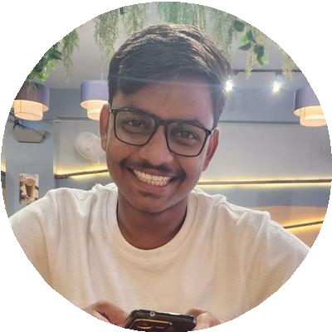
Ashish Shrivastava
Teaching & Managment
I am a hard working, honest individual. I am a good timekeeper, always willing to learn new skills. I am friendly, helpful and polite, have a good sense of humour. I am able to work independently in busy environments and also within a team setting. I am outgoing and tactful, and able to listen effectively when solving problems
honeyshri143@gmail.com
+91 9770554671
400 A Vishwas nagar mhow indore, Indore, India

WORK EXPERIENCE

Social science Teacher

Chameli devi public school Indore

Present

Social science and Economics Teacher
Little Angel's H.S. School MHOW
03/2023 - 07/2023 MHOW[Indore]

Social science Teacher and coordinator
Ambition Academy MHOW
2021 - 2022

