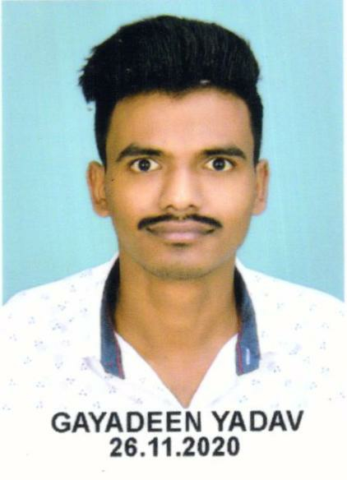

*Classroom management &clear communication

* planing curriculum and lesson plan

*conflict resolution

*up to date teaching methods

*behaviour management

*performance evaluation

*aware of technological advancement

*ability to grade assessment

*basic knowledge of all subject

I am very optimistic and cheerful, I can quickly integrate into the work environment. I am a person who loves my job, careful work and strong sense of responsibility. I can actively communicate with my friends in daily work to improve work efficiency. Communication is my strength.

Professional Skill

Work Experience

2016-2019 b. Com(hons) devi ahilya bai university indore (undergraduate)65%

* Major courses: Business Management, Information Management, Professional English, Accounting Foundation and DBMS

Education Background Education

* Mob: 8223977540
* Email: gayadeenyadav1996@gmail.com
* Address:
* Birthday:1996.07.04
* Location: indore
* Nationality：China

Job intention：Teacher

Self-evaluation

Hobby

Personal information

**PERSONAL RESUME**

*name Gayadeen yadav

2021_present teaching in sharda academy and oxy tutor MATHEMATICS AND REASONING,

* Banking aspirant if I gain 0.5 marks more so i was selected frrom sIN IBPS PO

* 2019_2021 worked as a home tuition teacher of MATH and ACCOUNTANCY
* Responsible for the training and skill students