SHIVAM SHARMA
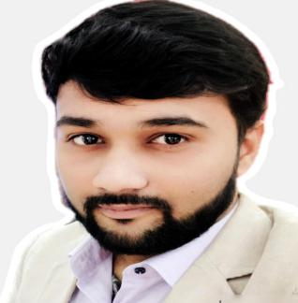
H. No. 73 A, Seth Mishrilal Nagar,
Near Escort Junior School,
Dewas (Madhya Pradesh) 455001.

Mobile : +91-9889886888 , 8574202202
E-Mail : shivamsharmajhansi@gmail.com
Objective : To contribute possible extent to the development of the organization and achieve new
highs with innovative, practical and efficient work experience.

Summary

- Educator of Reasoning (Bank, SSC & Railways Exams) in Sardana Tutorials.
Branch - Dewas (Madhya Pradesh)
Time Period : ( 27 July 2020 – Till now ).

- Faculty of Reasoning (Bank, SSC & Railways Exams) in Mahendra Educational Private Limited.
Last Branch - Indore (Madhya Pradesh)
Previous Branches - Nagpur (Maharashtra), Etah (U.P) , Gwalior (M.P.)
Time Period : ( 07 October 2017 – 15 July 2020).

Academic Credentials

- Post Graduate (M.Com) from Bundelkhand University Jhansi with 2nd division in 2016.

- Graduate (B.Com) from Sri Guru Harkishan Degree College Jhansi affiliated to
Bundelkhand University Jhansi with 2nd division in 2014.

- Intermediate passed from U. P. Board Allahabad with 1st division (72.9%) in 2011.

- Highschool passed from U. P. Board Allahabad with 2nd division (56.16%) in 2009.

Computer Skills & Other Skills

- 3 Month Certificate in MS Office & Internet from Vocational Training Institute Jhansi
(Cantonment Board Jhansi).

- Certificate in Course on Computer Concepts ( CCC )from National Institute of Electronics
and Information Technology ( NIELIT ).

- Typing Speed is 30 W.P.M in English.

- Certificate in Retail Induction Programme from Vodafone Circle Office ( UP EAST ) Lucknow.

Personal Dossier

Father’s Name : Late. Mr. Brij Mohan Sharma

Mother’s Name : Mrs. Kavita Sharma

Date of Birth : 19 March 1994

Marrital Status : Married

Permanent Address : Behind Krishna Talkies,
Near Tulsabai Dharmshala,
Sadar Bazar Jhansi. (U.P.) 284001.

Mobile No. : 09889886888 , 08574202202

Linguistic Abilities : Hindi and English

I hereby declared that all the information given by me is true and best of my knowledge & belief.

Date : 10 SEPTEMBER 2020 Thanks & Regards

Place : Dewas (M.P.) SHIVAM SHARMA

