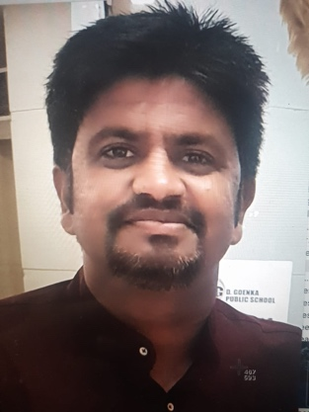
+919589373889,
ravicareer04@gmail.com

Ravi Tomar
Tutor
AGE
30
ABOUT ME
I aspire to work in an organization that inspires me with challenges and opportunities to grow not only as a professional but also as a person while applying my knowledge creativity.

Education

- Integrated diploma in travel and tourism management from Kuoni Academy of travels, Bhopal.
- Masters in tourism Management from IGNOU.
- B.A. from Devi Ahilya Vishwavidhyala ( DAVV), Indore.
- B.ED. from Devi Ahilya Vishwavidhyala (DAVV), Indore.
- Diploma in disaster management from IGNOU.
- PGDCA
- 10+2 (HSSCE) from MP board.
- 10th (HSSE) from MP board
Experience

- Worked with Tourism department M.P.
- Worked with Unique Public school for 1 year.
- Worked with Tomar academy for MPPSC 1 year (History, constitution).
- Worked with Konark IAS 3 year (constitution, History, current, social issue and health).

Professional Qualifications and Affiliations

- Ability to lead, motivate, and mentor a team.
- Excellent verbal and oral communication skills.
- Skilled in prioritizing, managing, and multi-tasking.
- Ability to work under pressure.
- Competent in planning the assignment and responsibilities.
Career Highlights

- MPPSC- 2015 & 2016 (Given Mains)
- Selected in MP tourism department.
- Department exam of sports and youth welfare.

Skills

- Quick learner

- Adaptive nature
- Can do data analysis as per requirement
- Flexible and responsible

Computer Proficiency

- MS Office (Word, Excel, PowerPoint, Outlook)
- Google sheets
- Zoom meetings
- Video editing

Languages

- Hindi
- English

Personal Interests

- Reading books
- Cricket
Personal Details

Father’s Name: Mr. Satyaveer singh Tomar Marital Status: Single
Mother’s Name: Mrs. Shashi Tomar Birthday: October 04, 1989
Nationality: Indian Gender: Male

Declaration
I, Ravi Tomar, hereby declare that the information contained herein is true and correct to the best of my knowledge and belief.

____________________________
Ravi Tomar

