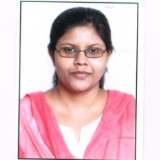
 rajsonam111@gmail.com
 8878688527
 F-9, New Minal Residency, JK Road, Bhopal, 462023, M.P.

FORUM IAS
2021- 2022
Content Developer (GS- Geography & Polity)
Faculty for Pub. Ad. & Indian Polity
Paper Setter (Prelims + Mains)

VERTEX CLASSES
NEET (Biology)
5th July 2017 - 22nd April 2019
Biology Teacher


MITESH RATHI CLASSES
1st August 2016 - 29th April 2017
Biology Teacher


2015
M. Sc. (Genetics) 72%
.
2012
B. Sc.


This thesis was completed by me during my masters which was published in the same year.

