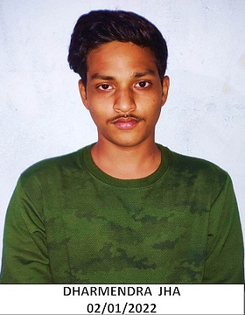 |  | DHARMendra jha
Profile  Contact  PHONE:  +917880261801  EMAIL:  Dharmendrajha479@gmail.com  Hobbies  Playing cricket  Listing song |  | EDUCATION  Passed 12th in 2018 with 66.67% from  Govt. school of excellence no.1 Morar Gwalior 474006  Graduated in 2021with 64% from  Govt. Shyamlal Pandaviya College Morar  fresher

