RESUME

Name : Dinesh Kumar Nagore
Add : 173/9A Saket Nagar, Habibganj, Bhopal
PIN : 462024
Mob : 7566981029
Email dinesh.nagore@gmail.com
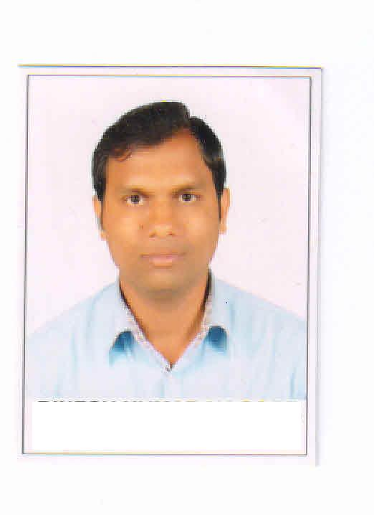
DINESH KUMAR NAGORE
OBJECTIVE:

To contribute best of my knowledge, skills and ability in growth of organization and also enhance my knowledge in the field of Education.

EXPERIENCE:
- Five year Experience as a Business Development Manager in British Institute New Market, Bhopal.
- Two year Experience as a Business Development Manager in Samiksha (IAS/PSC) Institute, M.P. Nagar, Bhopal.
- Two year experience at Indiacan Education Pvt. Ltd.(PEARSON) as a Business Development consultant.
- Two years experience in GATEFORUM (GATE/PSU/IES) institute as a Center Head, M.P. Nagar, Bhopal.
- Working in GATE ACADEMY,Bhopal as a Marketing Head.

QUALIFICATION & SKILL:
ACADEMIC:

- Master of Arts (Sociology) from B.U. Bhopal.
- Bachelor of Arts from B.U. Bhopal.
- Higher Secondary School Certificate Examination from Madhya Pradesh Board, Bhopal
- High School Certificate Examination from Madhya Pradesh Board, Bhopal

COMPUTER SKILLS:

    - Basic Knowledge of Computer
    - MS-Word, MS-Excel, MS-Power point, Language of C, C++.

EXTRA CURRICULAR ACTIVITIES:

    - Participated in Dance competition, Singing, Drama at College level.
    - “C” Certificate of NCC in Air-Wing.

PERSONAL INFORMATION:

Date of Birth : 30th-jan-1986
Gender : Male
Father’s Name : Shri N.P. Nagore
Permanent Address : 108, N-2 Bengali colony Habibganj, Bhopal, (M.P.)

Languages known : Hindi, English
Marital status : Married
Hobbies : Listening music, Reading worthwhile books

Area of interests : Education.

PERSONAL STRENGTH:
- Good grasping power and thinking ability.
- Ability to multi-task and work well within a team environment.
- To communicate people with confidence and positive attitude.
- Every time tries to achieve something worth while.

DECLARATION:

I hereby declare that the information furnished above is true to the best of my knowledge.

Place: Bhopal  Date : 28/02/2019 | ( DINESH KUMAR NAGORE )

