**Er. Rohit Singh Kushwaha** 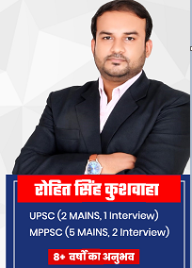

**E-mail:rohitsatna89@gmail.com**

**Mobile: +919589415988**

**Residence – Ayushman Residency, Rau, INDORE**

# *PROFILE*

* **Graduation - B.E (CS)**
* **Eight Years teaching experience in General Studies Subjects & Current Affairs.**
* **Good Command in Current affairs-International Relations.**
* **Currently working as HOD (Civil Services – English medium) in CivilJOBS, INDORE.**
* **Formerly worked as ACADEMIC Head in KOTHARI INSTITUTE (Rajwada branch), INDORE.**
* **Former ADO at LIC Bhopal.**
* **UPSC (2 Mains, 1 Interview).**
* **MPPSC (5 Mains, 2 Interviews).**
* **For Demo - My Current Affairs YouTube Playlist -**[**https://youtube.com/playlist?list=PLDrP8xJMNsmlEVcGHy89Wxh408FPN1PlX**](https://youtube.com/playlist?list=PLDrP8xJMNsmlEVcGHy89Wxh408FPN1PlX)
* **Willing to join your Academy/Institute’s as CURRENT AFFAIRS FACULTY.**

# *DECLARATION*

I do hereby declare that the particulars of information and facts stated herein above are true, correct and complete to the best of my knowledge and belief.

PLACE: Indore 

**Rohit Singh Kushwaha**