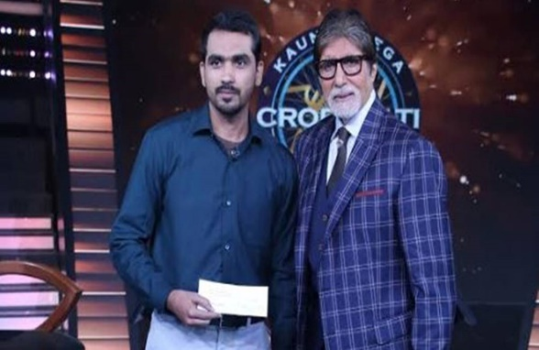

FAIZ MOHAMMAD
ABOUT ME CONTACT
An organized professional with proven teaching, guidance, and Mobile- 7987056609
counselling skills. Posses a strong track record in teaching effectively. faizkhan308@gmail.com
Ability to be a team player resolve problems and conflicts professionally Faiz Manzil Balaganj
skilled at teaching in a simple and entertaining manner. Hoshangabad (MP)
Pin– 461001.

EDUCATIONAL QUALIFICATION

- BE (Electronics & Communication) in 2010 with 71 % (RGPV Bhopal).
- Diploma in Mass Communication in 2019 (ALI GARH University).
- BEd from BU Bhopal , result awaited.(3rd Sem 94 %)
- Higher Secondary in 2005 with 79.50%(MP Board Bhopal)
- Higher School in 2003 with 79.60%(MP Board Bhopal)

TEACHING EXPERIENCE

- 7 years of experience in SSC, MPPSC and other competitive examinations as a teacher of Geography, MPGS and Science.
- Guided thousands of students in prestigious institutes like Mahendra’s and Mentors Academy in various cities like Bhopal and New Delhi.

ACHIEVEMENTS

- Winner of KAUN BANEGA CROREPATI Season 10. (12.5 lakhs)
- Impressed Mr. Amitabh Bachchan with my unique teaching style.
- Cleared UPSC civil services Mains examination in 2015.
- Qualified GATE examination in 2014.
- Have received 7 million+ views for my Shayri on YOUTUBE, title as KHUSH NASEEB HOO JO IS MULK KA MUSALMAN HOO.
- Won prize at national and state level in paper presentation on various technical and nontechnical topics.
- Honored by Maulana Azad Foundation Society at Dewas(MP) in 2018 for my excellent work in education.
- Honored at various programs as a poet and writer at national level.
- Selected as youth icon for state assembly elections at Hoshangabad in 2018.
- Have given seminars on how to crack various competition examinations in many cities.
- A motivational speaker in many programs.
- Organizer of Ashfaque Ullah Khan memorial program on 19 December of every year.
- Worked as a Nizamatgar (anchor) in many poetry programs in different cities.

HOBBIES

- Teaching, Poetry, Anchoring, Singing, Acting, Reading, Horse Riding.

PERSONAL INFORMATION

- Name - Faiz Mohammad Khan
- Father’s name - Mr.Sageer Mohammad Khan
- Date of birth - 30 August 1988
I solemnly declare that all the above information furnished in this document is correct and accurate. I take full responsibility for the correctness of the said information.

DATE-25 August 2022 (FAIZ MOHAMMAD) PLACE – Hoshangabad (MP).

