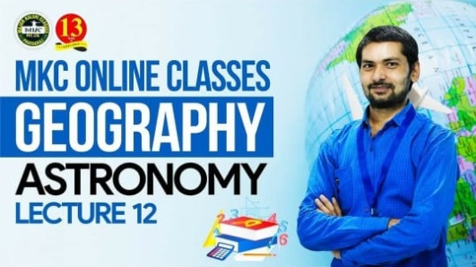

GANESH YADAV
KUSHINAGAR, UTTAR PRADESH.

Contact: +91 8726828631,

Email: gy01792@gmail.com
CAREER OBJECTIVE
Aspiring to work with an organization that offers responsible position where I can utilize my skills and capabilities to carve a niche for myself and effectively deliver towards contributing to the organization’s aspirations and also enhance my personal growth through continual upgrading of knowledge.
QUALIFICATION
Post-Graduation:
Master of Arts (Geography): 2013-15
(Deen Dayal Upadhyay University, Gorakhpur, Uttar Pradesh)
II Division
Graduation:
Bachelor of Arts (Geography & Political Science): 2010-13
(Deen Dayal Upadhyay University, Gorakhpur, Uttar Pradesh)
II Division
HSC (Science Stream- Biology):
L.P.K. Inter College, Gorakhpur – 2010 (UP Board)
I Division
SSC:
L.P.K. Inter College, Gorakhpur – 2007 (UP Board)
II Division
EXPERIENCE
- 1 year teaching experience in Exceed IAS as the Geography Faculty (From 2017 to 2018)
- 1 year teaching experience in The Council IAS/PCS as the Geography Faculty (From 2018 to 2019)
- 3 years teaching experience in Major Kalshi Classes Pvt. Ltd. as the Geography Faculty (From 2019 to 2022)
- 3 times written UPPSC Mains
- 3 times written MPPSC Mains
- 2 times written Lower PCS Mains

STRENGTH

Interpersonal:
- Soft-spoken,
- Problem solving and decision making,
- Ability to work in challenging environment and learning from adverse situations,
- Meticulous and a Quick-learner.
PERSONAL INFORMATION
Date of Birth | : | 1 July 1992
Marital Status | : | Unmarried
Languages Known | : | English, Hindi
Permanent Address | : | Barsaina, Kushinagar, UP (274207)
I hereby declare that above mentioned information is correct and best to my knowledge.

CURRENT PLACE: Kushinagar GANESH YADAV

