RESUME
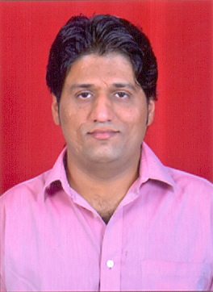
Name: Avinash Tripathi
DOB: 15/08/1989
Address: 1B-114, NCL Colliery,
Singrauli – M.P. (Pin- 486889).
Email: aviinashtripathi@outlook.com
Contact No: +91- 7073525078

Career Objective:
Seeking a full-time position as a Faculty member/ Tutor in Academic Institutions or in Coaching Centers where I can employ my skills and Knowledge to mentor aspirants for Competitive exams.

Concerned Subjects: General Science & Indian Polity (English medium)

Work Experience:
- Worked as a full time Faculty member in Maa Tutorial, Indore (from Oct ‘18 to Apr ‘19).
- Worked as a Research Assistant in TEXAS LAB under collaboration with Ramaiah University-Bangalore (on ad-hoc basis for 6 months).

Education (Technical & Academic):
- BE –Ramaiah University (Affiliated to VTU Bangalore) Dept of Biomedical Engg - Passed with CGPA =7.5 (2014 batch).
- SHSCE – CBSE Board (2005-06), DPS Nigahi (M.P.) - Passed with 70.4% Marks.
- SSE – CBSE Board (2003-04), DPS Nigahi (M.P.) - Passed with 84.6% Marks.
Computer Skills:
- Basics of MS-Word, MS-Excel, HTML and other Languages etc.

Language & Communication skills: Proficient in both Hindi & English (Soft and Very friendly Personality).

Expectations from employer:
*Conducive environment to learn, prompt and enhance professional skill.
*I aspect some blend of support and independence to attend any internship, training, seminars, or conferences, organized by the institution.

Skills & Strengths:
- “Can Do Approach” towards work.
- Optimistic and enthusiastic.
- Clear Comprehension and self –motivated.

Areas of Interest:
1. Faculty member & Mentor. 3. Office Administration.
2. Counselor and Consultant.

I hereby declare that the information furnished above is correct to the best of my knowledge. And I’m ready to serve as a dedicated professional wherever appointed.
Date: 30.05.2019.
Place: Singrauli.

