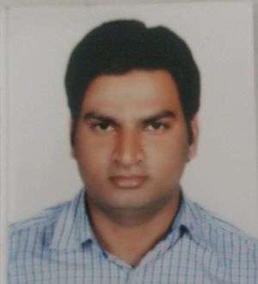

CONTACT DETAILS
Mobile: +91 9993449373
Address: F-406 PRK Residency Behind PNB Rau,Indore (4533
Mail: krishnakantyadav72@
gmail.com

PERSONAL PROFILE
Fathers’ Name:
Mr.M.L. Yadav

Mother’s Name:
Mrs. R.K. Yadav
Date of Birth:
27 Feb, 1989

PERSONAL SKILLS
- Excellent written and verbal communication skills
- Highly organized and efficient
- Ability to work independently as well as part of a team
- Well leadership skills and ability to motivate
KRISHNAKANT YADAV

CAREER OBJECTVE
To remain in touch with the field of civil services, thereby purse my interest and enhance my knowledge and have better command on my strong subjects.

HIGHLIGHTS
- MPSI 2014 QUALIFIED
- MPPSC 2014 MAINS WRITTEN
- SSC SI 2015 PRE QUALIFIED
- MPPSC 2015 MAINS WRITTEN
- MPPSC 2016 MAINS WRITTEN
- MPPSC 2017 MAINS WRITTEN
- ASSISTANT AUDITOR 2017 WAITING
- MPPSC 2018 MAINS WRITTEN
- MPPSC 2020 MAINS WRITTEN
- MPPSC 2020 FOREST MAINS

WORK EXPERIENCE
6 months- Worked in Research and Development department
of Satyadhi Sharma Institute, Indore
Presently- Working at The Winners Institute Indore from last
1 YEAR 8 MONTH
Engaged in Content writing and test series
Formation of MPPSC,Vyapam, SSC
Booklet and Notes work -1. Polity Hindi and English
2. History Hindi and English
3. Economy Hindi and English
4. Computer

SUBJECT COMMAND
- Madhya Pradesh GK
- Polity
- Geography
- Economics

ACADEMIC QUALIFICATIONS

B.E. (IT) | 2011 | CIIT, Indore, RGPV | 68.75%
MP BOARD (XII) | 2007 | HDHS School, Barwani | 66.88%
MP BOARD (X) | 2005 | HDJHS School, Barwani | 79.6%

Krishnakant Yadav
Place: Indore

