CURICULLUM VITAE  MAYANK JAIN  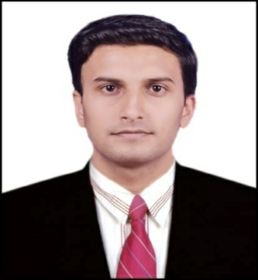  CONTACT ADDRESS  H.No33 Shivram Complex Beside Noble College Makronia Sagar, M.P.  C/o M.  MOBILE NUMBER  7999507821  E-MAIL  Mayankj54@gmail.com  PERSONAL DETAILS  Father’s Name:  Mr. S.C.Jain  DOB: 16th-Dec-1991  Gender: Male  Nationality: Indian  Languages Known:  English and Hindi.  MaritalStatus: Single . | CAREER OBJECTIVE  To work in a challenging environment where I can proof myself.  ● To gain an entry level position in the organization & to grow with the organization. I can contribute proficiently for my employer and where my experience, education, skills and abilities will be an asset.  ● Work as a team player and improve my inter personal Skills & leadership qualities.  ACADEMIC PROFILE  2013: Bachelor of Engineering (Mechanical ) from SRIT Jabalpur,  ( Marks Percentage : 71% )  2009: 12th – Govt.Higher Secondary School Bansagar MP BOARD  ( Marks Percentage : 82 % )  2007: 10th – Saraswati Shishu Mandir Bansagar M.P. BOARD  ( Marks Percentage : 85 %  2020 : M.TECH From Infinity Management College Sagar.  CERTIFICATES  - Designing Certificate In CATIA V5 from All India IT Association Delhi .

EXPERIENCE
- 2 yrs Mppsc mains written experience
- 2 Yrs teaching exp. In English medium school in english medium school kesli distt. Sagar
- 2 yr. working experience as production engg in coal mines Bilaspur c.g.

AREA OF INTEREST
- Designing Maths , Physics English

JOB SKILLS
- Ability to work both individually as well as in a team.
- Dedicated and consistent towards my work.
- Time management.

SOFT SKILLS

- Self confident to achieve goals.
- Self motivated, Hard worker.
- Very much eager to learn new things.

HOBBIES

- Collecting of information about new things
- Reading books and news papers
- Travelling, Net Surfing

DECLARATION

I hereby declare that all the information and facts given above are true
to best of my knowledge and belief.
Place: SAGAR MAYANK JAIN

