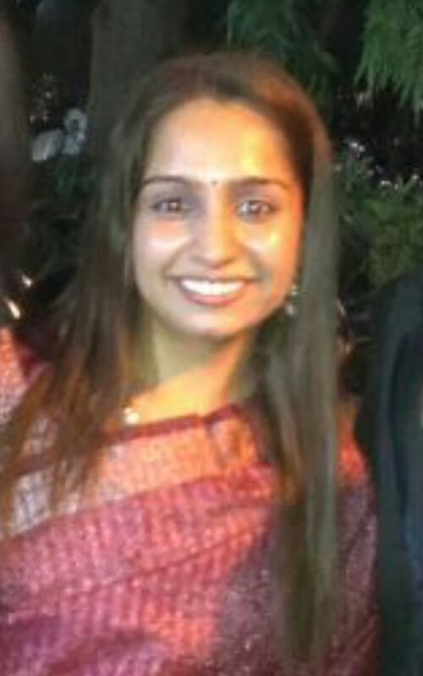
Neha Bhavnani
Contact info:
nehapurswani19@gmail.com
Facebook profile https://www.facebook.com/neha.purswani.334
Linkedin profile
https://www.linkedin.com/in/neha-bhavnani-5190671ba

Mobile : 6353155208
Objective: To work for a progressive organization that provides the best opportunities to grow and utilize my potential to the fullest.

Educational Qualifications
- Pursuing Ph.D.
- JRF awardee in Management (2016)
- Goldmedalist in MBA(HR).
- All India Rank 12 in CS Foundation
- Other details are as follows

Qualification | Year of Passing | Organisation. | Board/University | Percentage/Grade obtained
MBA | 2013-14 | K.S.School of Business management | Gujarat | A+ (Gold Medal)
BBA | 2011-12 | K.S.School of Business management | Gujarat | A+( 80.00 %)
H.S.C (commerce) | 2008-09 | St. Xaviers High schhol | Gujarat | 88.86%
S.S.C | 2006-07 | St. Xaviers High schhol | Gujarat | 81.38%

Experience
- Educator at Unacademy since April 2020
- Assistant professor at IHM, Ahmedabad
- 2 months Experience as an intern in Pantaloons (Aditya Birla Group) in its HR division; Ahmedabad

Projects Undertaken
Year | Name of the project | Details
First year | Industrial visit to crockery plant | We visited the plant ; learnt the process and presented its report.
Second year | Market Research on Telephonic instruments | We took a sample size of 2000 and evaluated customers’ preference for various telephonic instruments.
Third year | Feasibility Report on Non-stick cookware | We made a virtual non-stick plant; prepared financial reports of it for the time span of 5 years.
Fourth year | New Product Development | We prepared a new product called Foldable helmets and presented its feasibility Report
Fifth Year | Grand Project on HR | We prepared a project Report on Ergonomics.

Achievements
- Gold Medalist in MBA (HR) for the year 2013-14
- Secured 1st rank in Gujarat in CS foundation and 12th at All India level
- Finalist in Teacher’s Olympiad organised by Reliance Foundation
- Completed SCOPE (an exam undertaken by Gujarat Government in affiliation to Cambridge University to test Communication skills) with Excellent Grades.
- Awarded with a prize of “Pride of Sindhi Samaj” by Sindhu Samaj.
- Won the prize of “Best Elevator” at Gujarat youth Festival held at Zonal level.
- Awarded with several prizes and certificates at college and state level.

Extracurricular Activities
- I have been the co-ordinator of Cultural committee of KS School of Business Management. (This committee is responsible to hold all the cultural events of the college).
- Participated and won various prizes at various events at college and state level like debates, Extempore, Poetry etc.

Personal Information
Address | C-11, Saibaba Society, Sardarnagar, Ahmedabad
Nationality | Indian
Caste | Hindu
Gender | Female
Marital status | Married
Age | 23
Hobbies | Poetry writing, cooking, Reading novels, Dancing, Teaching.

The above information is true to the best of my knowledge.
Awaiting a positive Reply.

Thanks, and Regards
Neha

