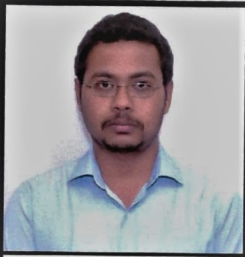
Naveen Parashar
SUBJECT - MATHEMATICS
Old Shivpuri, Shivpuri ( M.P. )
E-mail ID – naveenparashar81@gmail.com
Contact no – 07898556842
Career objective: -
To obtain a position in special education teaching that will allow me to use my strong and creative passion for the student development with skills and experience that will enable me to make a different at the place where I work.
Current status: -
- TGT (Mathmatics) in GURUKUL school, Dhamnod, district Dhar from march 2018.
- Taking online competition classes of bank, ssc, NTSE and state exams.
Teaching experiences:-
- 1 year teaching experience in Gaeta Public School, Shivpuri.
- 1 year teaching experience of self coaching of competition exams in Shivpuri.
- 1 year teaching experience in SHRI KANWARTARA HIGHER SECONDARY school Mandleshwar, dist Khargon (M.P.)
- 2 years and 6 months as TGT (Mathmatics) in GURUKUL school, Dhamnod, district Dhar from march 2018. Also taking pinnacle classes for NTSE 10TH CLASS.
- Faculty in online app (TARGET PEAK).
- Teaching mathematics of competition level since 2013 at many levels.
Education Qualification:-
- BE. (EC) from MPCT college. Gwalior. 2013.
- Intermediate (science) from mp board in 2008 with 74% marks.
- High school from mp board in 2006 with 83% marks. (Math’s marks 100/100).

Additive features:-
- All competition related to mathematics.
- NTSE, Olympiad classes (mathematics and logical reasoning)
- Cleared IBPS BANKING exams PRE and MAINS thrice.
Hobby
I like to write poems and participated in many kavi sammelans in India.

