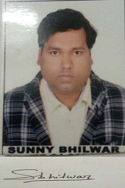 SUNNY BHILWAR
S/O SHRI GYASI LAL BHILWAR
DARGAH CHOK ,UTARKHANA
LASHKAR GWALIOR (M.P.)
PIN CODE -474001
MOB.NO -8982822718,9399547564
EMAIL ID sunnybhilwar123@gmail.com

