ABHISHEK JAIN

About Me

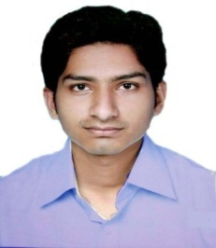
abhishaan89@gmail.com

+919981766303
September 25, 1989
5 Years experience
Sagar, Madhyapradesh

.
Education

Engineering, Computer Science 2012
B.T. Institute of Research & Technology Marks 67%
Sagar,M.P Division 1st
10+2 , PCM 2008
Govt.Ex.School, Rehli, Sagar, M.P Marks 76.8%
M.P.Board Division 1st
10th 2005
Saraswati High School, Rehli, Sagar,M.P Marks 73.4%
M.P.Board Division 1st

Computer Proficiency

- MS Office
- Typing
- Adobe Photoshop
- Operating System : Windows & Android

Work Experience

I have experience in the field of Education as a Computer Teacher from 8th feb 2015 To 23rd march 2020 in Strides Institute of Computer Technology.

Languages

- Hindi
- English

Personal Interests

- Singing
- Voice-Over acting & Dubbing
- Music Editing
- Music Recording
Personal Details

Father’s Name – Mr. Santosh Kumar jain(Ret. Govt.Employee)
Mother’s Name – Mrs. Sudha jain(Home Maker)
Date of Birth – September 25,1989
Gender – Male
Address – Gokuldham colony, kakaganj ward, Sagar, M.P. 470227

Declaration
I, Abhishek Jain, hereby declare that the information contained herein is true and correct to the best of my knowledge and belief.

____________________________
Abhishek Jain

