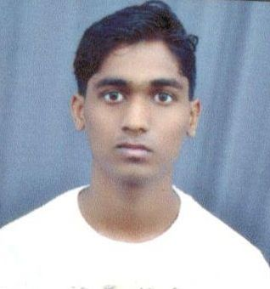
Pawan Kumar Patel

DOB: - 02nd March 1996
Contact no: - +91 8435188947
Email: - pawanpatel0203@gmail.com
Permanent address: - Room No. B7 Irrigation Colony, Old Panna Naka Chhatarpur, M.P

OBJECTIVE:-

To join a professionally managed organization making optimum utilization of my knowledge, experience and abilities that offer professional growth while being resourceful, innovative and flexible.

ACADEMIC CREDENTIALS:-

Qualifications | Institute | Board/University | Year of passing | Percentage
B.E. Machanical  Engineering | Pt. Devpraphakar shastri college of technology chhatarpur M.P | R.G.P.V. | 2015-16 | 7.64%  CGPA
XII | School for Excellence, Chhatarpur | M.P. Board | 2012 | 79.60%
X | School for Excellence, Chhatarpur | M.P. Board | 2010 | 80.00%
.
SOFTWARE EXPOSURE:-

- Win XP,Wista, 7, 8, Microsoft office

- Pro-E

KEY SKILLS:-
- Excellent Mathematics Skills
- High level of professionalism.
- Active listener.
- Team player.
- Confident.
- Eye for detail.
- Quick learner.

EXTRA CURRICULAR ACTIVITIES:-
- Active Sports Person Of College.
- Join Scout and Guide in school.

MAJOR TRAINING:-
- Department : Indo German Tool Room, Indore
- Duration : 14 Days
- Key Learning : Making of Micro tool

CERTIFICATE:-

- Pro-E

- MAJOR TRANING CERTIFICATE.

PERSONAL INFORMATION

- Name : Pawan Kumar Patel
- D.O.B : 02 March 1996
- Father’s Name : Ramroop Patel
- Nationality : Indian.
- Language : English & Hindi
- Hobbies &interest : Listening to music, Net Surfing, Cricket,
- Skills/Strength : Disciplined, Flexible & Adjustable nature.

DECLERATION:-
I consider myself familiar with Mechanical Engineering Aspects. I am also confident of my abilities to work in a team.
I hereby declare that the information furnished above is true to the best of my knowledge

(Pawan Kumar patel)

