Curriculum vitae
Add.:- Rajnagar colliery distt. Anuppur M.P.
Email:- rkushwaha0@gmail.com
Cont. No.:- 6260305668
Father:- Mr. Chhote lal kushwaha
Mother:- Mrs. Rajwati kushwaha
DOB:- 10 july 1987
Nationality:- Indian
Marital Status:- Single
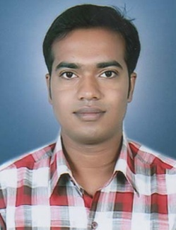
Ram Manohar Kushwaha
Career Objective:

To work in an organization which gives me ample opportunity to showcase my talent and in turn whatever I do, I ensure that I do it in the best possible, effective and an ethical manner.

Academic Qualifications:
 ➢  Bachelor of Engineering: - B.E.R.I. Bhopal, M.P. in 2011. WITH 68.66%
 ➢ Higher Secondary: A.H.S.S., in 2005. WITH 85%
 ➢ High School: A.H.S.S.in 2003. WITH 80%
Work Experience:
Having 06 Year Experience in various educational Institutes as a
REASONING FACULTY
- Currently working PINNACLE CAREER INSTITUTE Bhopal from october 2017
 ➢  worked at Career Power Rewa Branch from july 2016 to September 2017
 ➢ Worked at Institute MAHENDRA EDUCATIONAL PRIVATE LIMITED, Raipur branch from april 2016 to July 2016.
 ➢ Worked at PINNACLE CAREER INSTITUTE SATNA from april 2015 TO april 2016
 ➢ Worked at SUCCESS POINT COACHING SATNA from april 2013TO april 2015

Strengths:
- Positive thinking: Showing positive attitudes for execution of task.
- Leadership: Leading the team towards team work and coordination.
- Decision making: Taking precise decisions for achieving the Goal
Hobby
➢ Reading books.
➢ Swimming.
➢ Music.
Personal Information:
Father | Mr. Chhote lal kushwaha
Mother | Mrs. Rajwati kushwaha
DOB | 10 july 1987
Sex | Male
Nationality | Indian
Marital Status | Single
Language | Hindi, English
Permanent Add. | Rajnagar colliery distt. Anuppur M.P. 484446

Declaration:
I hereby declare that all the above information given by me is true to my consent.
Place: BHOPAL
Date: RAM MANOHAR KUSHWAHA

