(RESUME)
NAME: ALI SHER SHAH
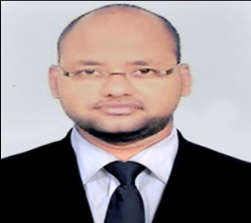
ADDRESS: PAWAN SUT COLONY,
HURAWALI TIRAHA, MORAR, GWALIOR
Mobile No. +919582791416
Email: advocateshah1985@gmail.com

Profile
A Dynamic, Innovative, Analytical and Highly committed legal professional. Good experience in legal research, writing, presentation, Good Communication and organization skills with the will and determination needed to succeed. Adapts quickly to new environments and thrives on multiple tasks and an orientation towards learning and accepting intellectual challenges. Seeking dynamic and challenging opportunity to prove my credentials.
Highlights of Qualifications

- Completed LL.B.(2015) from –LAW CENTRE-I, FACULTY OF LAW, UNIVERSITY OF DELHI.

- Completed LL.M. in Criminal law(2019) from ARMY INSTITUTE OF LAW, MOHALI, PUNJAB.

Legal Experiences
- Independently Handling Criminal, Civil, Labour and MACT Cases in Gwalior District court.
- Working with The Apex Jurist law firm, Netaji Subhash Palace, New Delhi.
- Working with Harish Kumar and Associates, Delhi High Court.
- Working with Ramlal and Associates, Delhi High Court.

Area of Specialization
- Legal Research abilities, Drafting Skills, good knowledge of procedural laws etc.
Area of Interest
- Criminal Law, Constitutional Law, Jurisprudence, Labour Law, Insurance law ,Intellectual Property Law, Family Law etc.
Bar Admission
- Enrolled as an advocate with Delhi Bar Council in 2015
- Enrolment No-D/3859/2015
Important Activities:-
- Worked with Members of Parliament (Lok Sabha & Rajya Sabha) and gained insights into working of Parliament of India.
Additional Information
- IT skills (M.S. Word, M.S. Access, M.S. Outlook, Excel, Power Point)

- Good knowledge of procedural laws, Good Editorial skills, Project Management skills, Good in Public dealing and Effective Speaker.

- Qualities-Teamwork, Creative , Disciplined, Reliability, Persistence, Determination, Compassionate and Time-Management.

I declare that the details above are correct and true to the best of my knowledge.
ALI SHER SHAH
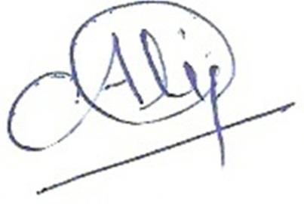
(Place: Gwalior)

* All certificates may be produced on demand.

