CURRICULUM VITAE
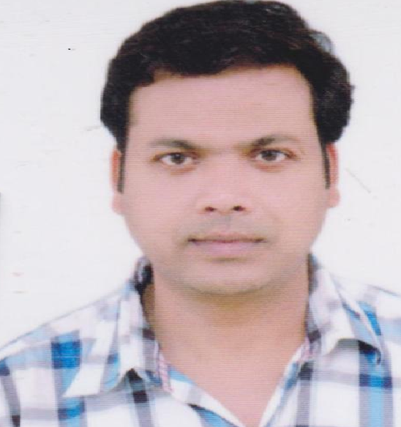

MAHESHWARI PRASAD 314-A SURESH NAGAR THATIPUR
Maheshwariprasad18@gmail.com MORAR GWALIOR MP 474011

Mob. 9926261880

OBJECTIVE:

Seeking a position to utilize my skill and abilities in the field of electrical that offers professional growth while being resourceful, innovative and flexible.

Personal skill:

Comprehensive problem solving abilities, willingness to learn, team comparator be honest.

Educational qualification:

- ME (ISD) from MITS GWALIOR WITH 67%(2006)
- BE (ELECTRICAL) FROM GOVT ENGG. COLLEGE REWA (MP)WITH 60%(2004)
- HIGHER SECONDARY FROM MP BOARD
- HIGH SCHOOL FROM( KV NO.1) GWALIOR

Computer exposure

- Operating system MS DOS WINDOW 98,XP & 7
- MAT LAB SOFTWARE 6.1,PLC
- POWER WORLD SIMULATOR

Project undertaken

Design of counterpoise earthing system at 220KV sub station

ME THESIS

Security constraints optimal power flow(SCOPF) with power world simulator software

Subject of interest

- Machine
- Power system
- Basic electrical
- instrumentation
Work Experience (12year)

- 4 year teaching experience as a lecturer in NITM college Gwalior.
- 1 year teaching experience in LNIT Gwalior.
- 1 year in GEC Gwalior .
- 5 year teaching experience in IPS college Gwalior form june2012
- Presently working as asst Prof.Deptt. Bsc (PCM) Aryansh college arts and management Dhaneli bada gown and NDA (PHYSICS)Jadon IAS/PSC

Personal information

- NAME MAHESHWARI PRASAD
- FATHER NAME BADRI PRASAD
- DATE OF BIRTH 18/10/1978
- GENDER MAIL
- MARITAL STATUS MARRIED
- NATIONALITY INDIAN
- LANGUAGE KNOW HINDI & ENGLISH
- RELIGON HINDU

EXTRA CURRICULAR ACTIVITIES:

- Handling of practical exam
- Work as a HOD
- Work as a asst. exam supt.
- Work as a teacher guardian.
- Work in antiragging/discipline committee.
- Head of alumni association/counseling cell
Declaration

Here I delare that the above mentioned information are true to the best of my knowledge and belief

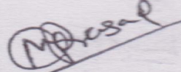
Date: 13/07/2018

Place: GWALIOR Maheshwari Prasad

