Vivek Kumar Singh  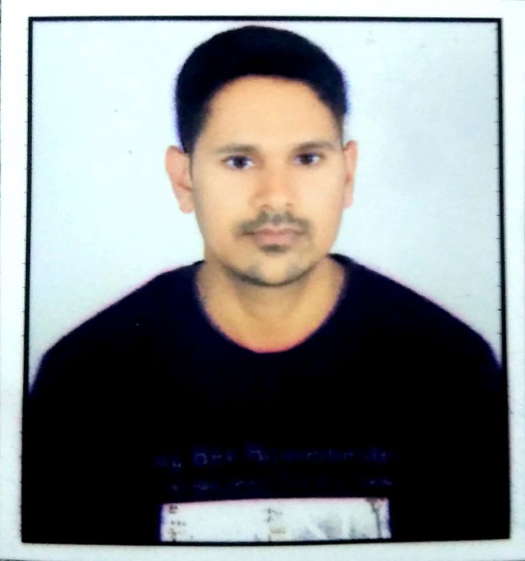  Address for Correspondence:  H.No.-334,  Gulab Bag Colony  Near Dewas Naka  Indore-452001  (Madhya Pradesh)  E-Mail:  vicky241288@gmail.com  Contact no:  9827932685  Permanent Address:  At-Sahijana  House No.-138  Ward No.-08  Dist.-Grahwa  (Jharkhand)  Personal Data:  Date of Birth : 24-12-1988  Father’s name: Shri. Ajay Singh  Mother’s name : Smt. Kalawati Devi  Gender : Male  Nationality : Indian  Marital Status : Single  Proficiency : Hindi, English.  Hobbies:  Swimming, Cooking, And Travelling.  Strength:  Honest, Self Confident & Disciplined.  Area of Interest:  TOM,SOM,Mechanics  Technical Skills:  # O.S: Windows(2000,XP,07,08,10)  # Basic Course: Pro-E(wildfire 4.0,5.0)  #Auto Cad  Self Appraisal:  I am honest, hardworking, patience, always willing to learn, quick learner & goal oriented. | Career Objective  - Looking for a position of Special education teaching to use my strong passion for student’s development, together with skills and experience that will enable me to make a significant difference at your institute.  Academic Profile  - Master Degree: M.E pursuing ( Design of Mechanical System) from Swami Vivekanand College of Engineering affiliated to R.G.P.V Bhopal with 7.5 cgpa till 3rd sem.  - Bachelor Degree: B.E (Mechanical Engineering) from Malwa Institute of Technology, Indore (M.P) affiliated to R.G.P.V Bhopal with an aggregate of 70.06% (2011)  - Intermediate: In 2006 from Marwari College Ranchi(Jharkhand) affiliated to Jharkhand Academic Council with 56.22% marks.  - Matriculation: In 2003 from Govind High School Garhwa (Jharkhand) affiliated to Jharkhand Secondary Examination Board,Ranchi with 58.8% marks.  Professional Experience  1.Working in Prayog Institute as a Physics Faculty.  2.Worked as an Asst. Professor in Prestige Institute of Engineering Management and Research, Indore from 2 August2018 to 21 January 2019.  3.Worked as an Asst. Professor in Acropolis Technical Campus, Indore from 26July 2013 to 23 July 2018.  4.Worked in as a Lecturer in Oriental University, Indore from March 2012 to July 2013.  5. Worked in Navin Infra Solutions Pvt. Ltd.(Authorized Dealer of Volvo) As a Service Engg. from July2011 to January2013  Training  # Two weeks industrial training from Bokaro Steel Plant (SAIL).  # Four week industrial training from Aditya Birla Chemicals India Ltd.  Academic Project  - Design of Ultrasonic based fumigator under variable Flow condition to control Humidity of a control Volume  - Study of Hydraulic Accumulator.  - Pedal Powered Washing Machine.  - Portable Drilling Machine.  Certification  - Pro/Engineer Professional 2.0 from IGTR  - Auto Cad from IGTR  - C++ from AISECT  - JAVA from AISECT  - Visula Basic from AISECT  - DCA from DUX  Work Shops & Participations  - Essentials of MATLAB & Simulation at Oriental University  - Faculty Coordinator in Aerotrix all India Ornithopter Zone-USA  - Faculty Coordinator in GKDC Pre Final Round-2015 under Isnee.  Declaration  I hereby declare that all the above information given are true to the best of my belief and knowledge.  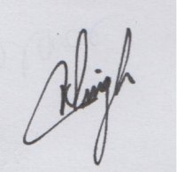  Place: Indore VIVEK KUMAR SINGH

