ROHIT RANJAN THAKUR
Faculty UPSC CSE
English & Hindi Medium
Mob No. : 6200439764
Mail – rrtpatna1@gmail.com
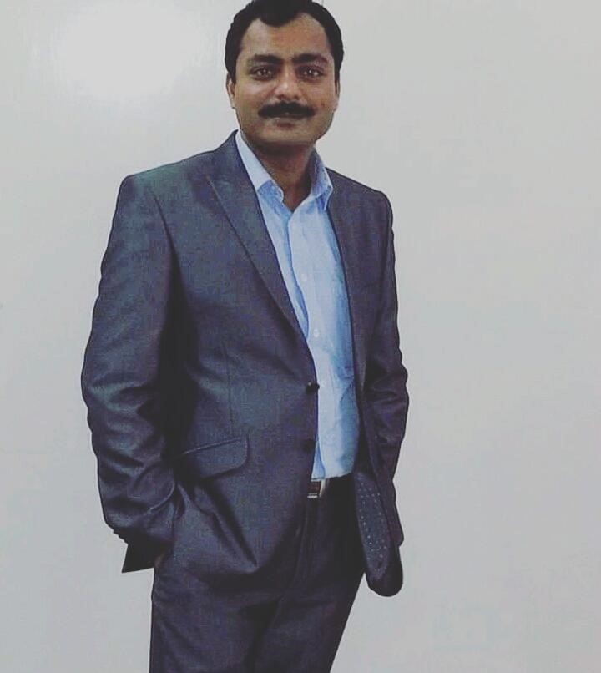
________________________
DOB : 06 – 12 – 1978
Nationality : Indian
Marital status : Married
Address : kali Mandir road , Sanjay
Gandhi Nagar
Kankarbagh , Patna - 800026
Bihar

OBJECTIVE
To prove my self an asset for the company. Empowering the Coming generation through Education and Value inculcation.
________________________
Specialization -
Associated with different reputed
Coaching institutions since 2008 as
Full Time Faculty member ,
Visiting / Guest faculty , Course
Director , Academic Head & Center Director
________________________
Work Experience
- 14 years of teaching Experience
- 6 years Experience as Academic
Head |Course Director | Center
Director ( Government job
Division ) ( General Studies )
- 8 - Years Teaching experience with reputed coaching institutions for UPSC CSE Domain

Organization :-
Banking service Chronicle (BSC ) -
( Banking , SSC , Railways, LIC ,
FCI Exam ) ( 2008 – 2011 )
Academic Head |Course Director |
Center Director ( Bihar )
TIME : Course Director |
Academic Head - SSC & Banking
Examinations ( 2012 – 2013 )
Career Power : Visiting Faculty
Banking and Economy ( 2017 – 18 )
Aastha IAS Academy , Delhi
( Patna Branch ) ,
Mantra IAS Academy, Shankalp IAS Academy ( Patna, Bihar) :
Visiting Faculty ( Indian Economy
& Indian Constitution and Polity ,
Essay , Ethics & Integrity, IR ,
Social justice, Indian Society)
( 2014 – 18 )
Chanakya IAS Academy - Visiting
Faculty UPSC CSE ( General
Studies Preliminary & main,
Sociology – Optional paper Patna
Branch ( 2017 – 2019 )
Patanjali IAS Academy ( Patna ) :
Academic Head | Course Director
UPSC CSE Domain ( 2019 – 2020 )
Tejas IAS Academy (CG) Faculty ( Visiting ) ( 2019 – 22 )
Sardana IAS Academy ( MP ) :
Faculty online ( 2021 ) ( Visiting )

Rishikul IAS Academy ( MP ) , Tejas IAS Academy ( CG ) as Visiting Faculty ( 2020- 22)
UPSC CSE ( Civil Services Exam)

Current Assignments : From March 2022 – December 2022
VAJI RAO IAS ACADEMY Pvt.
Ltd. ( Bhubaneshwar & Delhi Branch)
Subjects: Indian Constitution and
Polity, Indian society, Social Justice, International Relations, Internal Security, Ethics .
Optional paper: Sociology & PSIR
Chahal IAS Academy, Patna
Branch ( January - February 2023)

Currently worked with The
Success IAS Academy, Hisar
( From 1st May 2023 to 1st May 2024 )

Mentor / Faculty :-
Faculty : General studies : Indian
Constitution and polity,
Indian Economy for UPSC CSE , State Civil Services ( Preliminary & Mains).

UPSC CSE Mains : social justice ,
Indian society , Internal Security,
International relations, Ethics & Integrity, Essay.
Faculty : Optional paper –
SOCIOLOGY , PSIR ( UPSC CSE )
________________________
▪ Medium of teaching : English and
Hindi
________________________
EDUCATION
Post Graduation - Political science
( IGNOU New Delhi ) Year : 2017
– 2019
Bachelor of Education – 2013
( RDVV , Jabalpur, MP )
Graduation - Economics , Political science, English language and literature , Year: 1996 – 99 ( RDVV , Jabalpur, MP )
Intermediate - Political science ,
History , Economics , Year - 1994 –
1996
Board- Bihar School Examination
Board , Year : 1994
________________________

Interest for relocation : For the right opportunity I am definitely willing to relocate. I don’t have any issue .

Reason for Change : For a better opportunity , more challenges, and career growth .
_________________________
AWARDS & ACKNOWLEDGEMENTS

▪ Awarded at college level for extracurricular activities .
▪ Cleared UPSC CSE - 4 times ( 2005,2006,2007,2008 )
▪ Cleared State Civil Services Exam ( UPPSC , BPSC , MPPSC )
7 times .
___________________________
Regards
Rohit ranjan Thakur
Faculty
UPSC CSE
Visiting / Guest faculty
Patna , Bihar

________________________

