Resume

Personal details
Name | pawan kumar mishra | 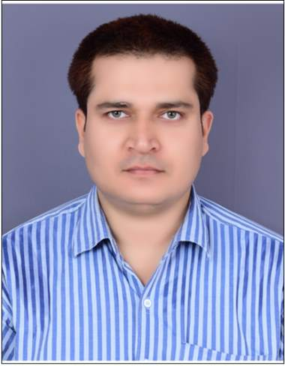
Address | Ballia uttar pradesh 277001
Emailid | meetpawanmishra@gmail.com
Mobile number | 9415160842/ 8563920333
Marital status | Single
Whatsapp number | 9415160842
dob | 31july 1988
# Looking For A Admin Operations Manager Or Assistant Manager Post.
# Master Of Admin And Operations
Educational Qualification
1-10th Pnic Inter college Ballia Uttar Pradesh
2-12th Pnic Inter college Ballia, Uttar Pradesh
3-B.tech Computer Science and Engg from Spcet college Mohali, Punjab
4-University- Punjab Technical University Jalandhar
Work experience
3 years -working as a faculty and do operational and admin work in coaching institute.
Project – Branch Head /Admin /Operations /Human Resource /Infra/IT/Security/Seminars
Team member -20
Title- Branch Manager at Mahendra Educational Pvt Limited Rewa (486001)
Madhya Pradesh
Duration -11 months from sep 2018 to till date
Current working –Mahendra Educational Private Limited
Skills- KRA and ARA
1- Deep knowledge of SSC ,Banking ,Railway State level Exam, State PSC and UPSC civil service, Exam Entrance Examination
2-Soft spoken, good communication skills ,
3-Very familiar about exam pattern of all government job Competitive examination
4-Deep knowledge of admin work and operational works , and basic knowledge of human resource.
5-Ability to handle big branch and take responsibility of overall operations (admin and academic both)
6-Ability to work with team or without team.
7-Taking interview upto senior executive and senior counsellor level
8-leave approval through hrms portal of all employee. as well as handle new joining ,transfer and resignation ,
9- Approve travel request and travel expenses.
10-Also see legal matter of the branch like (burgulary, legal notice ) notice received from local bodies.
11-Easily handle branch infra work from maintenance to replacement of infra items
12-Also Intermediate knowledge of branch IT material like s/w installation, s/w update, formatting, projector setup, cctv cameras, printer setup.
13-Ability to increase the Branch business.
14-Easily relocate from one location to another.
15- Patience level is very high.
16-Honesty is 100% , Straight forward but always keep 100% diplomatic approach for company welfare and growth.
17-Arrangement skills is very high.
18- Very familiar About Banking , SSC, Railway As Well As All Government Job Examination.
19-Good motivator and active listener.
20-247 thinking about current company.
21-Ready to work in Pan India.

I hereby declare that the information provided above is true to the best of my knowledge .
Date-29th july 2019 sign

