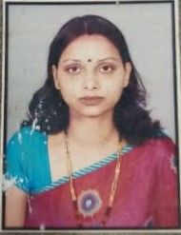
Mobile: +91-9691866627
Email:richa22verma12@gmail.com
Name- Richa Verma

Career Objective

Seeking a career to utilize my knowledge, personal skills to gain comprehensive understanding of a reputed organization so as to take responsibility and contribute significantly to organization’s growth and broaden my skills further.

Academic Record

B.ED AISECT University,MP with 67% in 2017.
- Master Of Arts from DAVV,Indore with 54% in 2013.
- Bachelor Of Arts from CSJM University, Kanpur with 62% in 2005.
- H.S.C from UP Board in 2002 with 54%.
- S.S.C from U P Board in 2000 with 49%

Work Experience

- 7 Years of Teaching Experience at Sanmati H.S.School, Indore.
- 2 Year Experience of Class 11th (Humanities).
- At Present taking Class 9th Social Science.
- 3 Years’ Experience in KYMS Academy.
- 7 Year’s Experience in RV Institute.

Personal Profile

- Husband Name : Mr. Deepesh Verma
- Date of Birth : 1st December 1983
- Strength : Hardworking , High Self Esteem , Result Oriented
- Hobbies : Writing , Singing , Travelling to New Places
- Languages known : English, Hindi.
- Permanent Address : 3/5, Murai Mohalla Chawni, Indore
- Marital Status : Married

Declaration
I hereby declare that all the information given by me is true to the best of my knowledge.

DATE Richa Verma

