CAREER OBJECTIVE:-
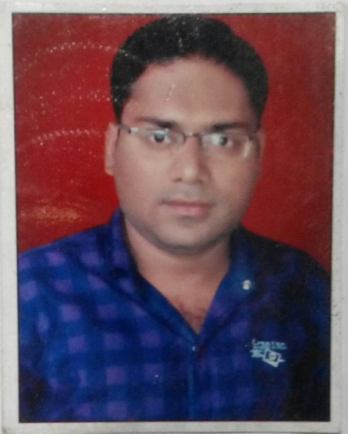
To obtain responsibilities achieving organizational goals where I can contribute in the area of education for further development of my abilities, skills effectively for the success of the organization along with improving my personal & Professional skills.

WORK EXPERIENCE:-
- Working as P.G.T. Economics in Christukula Mission I.C.S.E. School in Satna (MP) since 17 August 2017 to till the date.
- Working as teaching faculty of Economics in Christukula Mission Women's College in Satna (MP) since 21 August 2017 to till the date.
- Worked as T.G.T. Social Science with DAV Public School in Bishrampur, (C.G.) since 27th June 2016 to 30th April 2017.
- Worked as P.G.T. Geography with Kendriya Vidyalaya in Bilaspur, (C.G.) from 1st April 2016 to 22nd June 2016.
- Worked as P.G.T. Economics and H.O.D. of Social Science with Modern Educational Academy in Bilaspur, (C.G.) since 10th July 2013 to 22nd February 2016.
- Worked as T.G.T. Social Science and Senior computer operator with Paramount Academy, Jaithari (M.P.) since July 2010 to June 2013.
JOB SKILLS:-
- Ability to work in a team.
- Committed to work in project deadlines and schedules.
- Organized and well structured at work.
- Effectively use of audio – visual teaching aids.
- Using effective teaching methods.

SOFT SKILLS:-
- Ability to grasp and learn new technology and teaching methods quickly & accurately.
- Very enthusiastic and highly motivated with a Positive attitude.
- Flexibility & Adaptability.

EDUCATIONAL QUALIFICATION:-
Educational Details | University | Year of completion
MA in Economics | Annamalai University, Annamalai Nagar Tamilnadu | 2017
B.Ed | MP Bhoj Open University, Bhopal | 2015
PGDCA | Vinayaka Mission University, Salem, Tamilnadu | 2010
MA in Geography | Awadhesh Pratap Singh University, Rewa (M.P.) | 2009
BA | Awadhesh Pratap Singh University, Rewa (M.P.) | 2007

ACHIEVEMENT:-

Qualified UGC -- NET (Geo.) June 2013.
Qualified CTET (Social Science) September 2018.

DECLARATION:-
I hereby declare that all the information and facts given above are true to best of my knowledge and belief.

Date:
Place: Jaithari (M.P.)

