SHIVAM SHARMA

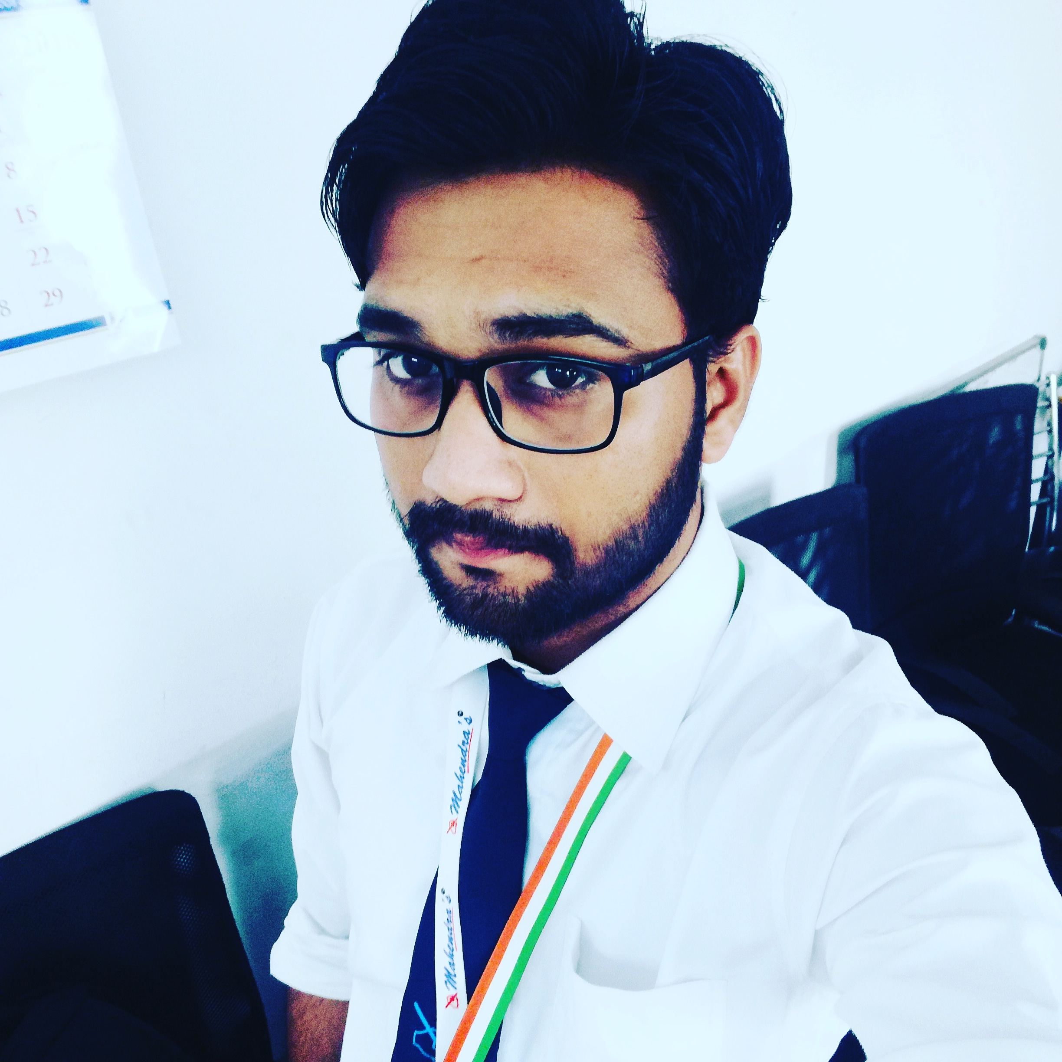
Behind Krishna Talkies,
Near Tulsabai Dharmshala,
Sadar Bazar Jhansi (U.P.) 284001.
Mobile : +91- 8574202202

E-Mail : shivamsharmajhansi@gmail.com

Objective : To contribute possible extent to the development of the organization and
achieve new highs with innovative, practical and efficient work experience.

Summary

- Faculty of Reasoning in Mahendra Education Private Limited (Mahendra’s)

Current Branch – Indore Branch (Madhya Pradesh)

Previous Branches – Nagpur Branch (Maharashtra), Gwalior Branch (M.P.) , Etah Branch ( U.P.)

Time Period : ( 09 October 2017 – Till Now ).

Academic Credentials

- Post Graduate (M.Com) from Bundelkhand University Jhansi with 2nd division (49.80%) in 2016.
\\\\\
- Graduate (B.Com) from Sri Guru Harkishan Degree College Jhansi affiliated to
Bundelkhand University Jhansi with 2nd division (57.56%) in 2014.

- Intermediate passed from U. P. Board Allahabad with 1st division (72.9%) in 2011.

- Highschool passed from U. P. Board Allahabad with 2nd division (56.16%) in 2009.

Computer Skills& Other Skills

- 3 Month Certificate in MS Office & Internet from Vocational Training Institute Jhansi
(Cantonment Board Jhansi).

- Certificate in Course on Computer Concepts ( CCC )from National Institute of Electronics
and Information Technology ( NIELIT ).

- Typing Speed is 30 W.P.M .

- Certificate in Retail Induction Programme from Vodafone Circle Office ( UP EAST ) Lucknow.

Personal Dossier

Father’s Name : Late. Mr. Brij Mohan Sharma

Mother’s Name : Mrs. Kavita Sharma

Date of Birth : 19 March 1994

Marrital Status : Married

Address : Behind Krishna Talkies,
Near Tulsabai Dharmshala,
Sadar Bazar Jhansi. (U.P.) 284001.

Mobile No. : 08574202202

Linguistic Abilities : Hindi and English

I hereby declared that all the information given by me is true and best of my knowledge & belief.

Date : 17 September 2019 ( Shivam Sharma )
Place : Indore (M. P) . Thanks & Regards...✍

