Sourabh tiwari 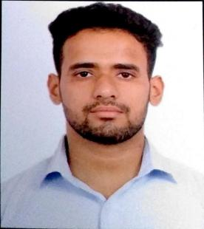
EE-736
mr.sourabh35@gmail.com
7898904477
-----------------------------------------------------------------------------------------------------------------------------------------------------------------------------------

Education

Master:-
School of studies, Jiwaji university. Graduated, July 2021
PG Board,Gwalior, Madhya Pradesh CGPA 6.6
Division 1

Bachelor:-
Govt. Shyamlal Pandviya College Graduated, July 2017
UGC Board, Gwalior, Madhya Pradesh Marks 53%
Division 2

10+2 Graduated, July 2014
mp board Marks 59%
Gwalior, Madhya Pradesh Division 2

Work Experience

1 year in Eduvista
As a teacher

Achievements:

- NCC- C certificate holder with b grade
- Selected for NATIONAL INTIGRATION CAMP from Madhya Pradesh for national level.
- Powerlifting state level championship (first position)

Personal Details

Father’s Name: Mr. Rakesh Tiwari
Marital Status: Single
DOB: April 26,1996
Nationality: Indian
Gender: Male
Hobbies: singing, gym reading and teaching.

