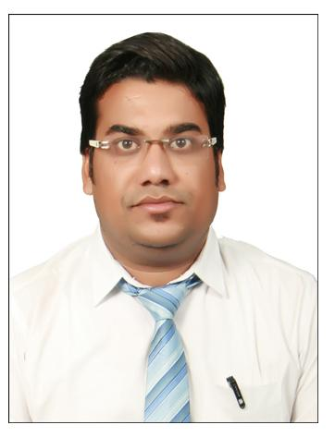
00
VARUN AGRAWAL

Address : H.No. 284, Opp. Arihant Hospital, Gumasta Nagar, Indore (M.P.)
Contact No. : 8118853800 - 9424351773
Email ID : varun.agrawalsatna@gmail.com

CAREER OBJECTIVE
To give the best with my full capability, determination & optimism seeking a challenging career position where unique blend of my talents can be effectively utilized by a company offering long- term opportunities for professional growth to recognise my prior experience analytical skills & dedicated performance.
SUMMARY:

I am Post Graduate in Management (PGM) with major in Finance and minor in Marketing & well versed with MS OFFICE (EXCEL, WORD, and POWER POINT). I am having 4+ years of Professional expertise in NBFC & Education Industry.

WORK EXPERIENCE
Bhawti Academy 2020 to Present

I am Taking a Class of General Awareness & Current Affairs As Well As Indian Economy Classes Academic Portion Covered.

Pinnacle Carrer Institute, Paramount Coaching Institute, Career Launcher 2017 to 2019
Has been associated with above mentioned training institute in Indore as G.S. & Current Affairs, Static, GK Faculty

Mahendra Educational Private Limited July 2013 – Mar 2017 Faculty of General Awareness

- I organised PRT Session (Pre Recruitment Training Classes) at many location…
- Created and increased brand awareness through participation in Educational Fairs, Canopy.
- Share information of with the students Banking & Insurance Sector Marketing General Awareness Indian Economy.
- Give presentation of career in bank and promote the scope of banking field to students, parents for the future prospective.
- Coordinated administrative activities.

Reliance Capital Asset Management Ltd. Dec 2008 – Nov 2010
Branch operation executive (Satna)

- Expertise in handling a diverse range of operations in the financial Sector.
- Handle the Customer portfolio assign as a Operations Officer and acquire knowledge of all investments products of the co.
- Operate the Work flow processes including all application form Liquid Fund, Debt Fund & Equity Fund opening formalities and KYC- norms of co.
- Handle the marketing of All SIP & Lump sum Investment Product of AMC with Coordination of Operational part also.
SUMMER INTERNSHIP
Birla Corporation Ltd, Unit – Satna Cement Works Ltd. SATNA (Cash Management Services) May 2007 – June 2007
- SBI provides cash management services to corporate clients under the brand name SBI fast funds available in shortest time.
- SBI fast ensures optimization of collections and payout while ensuring predictability in the cash flows.
- Enhanced Liquidity.
- SBI fast ensure getting funds in time quick transfer, account reconciliation, easy disbursement, controlled processes and customized MIS.
- Interest cost reduction on borrowings.
- Interchange of information between Treasury & operation Units. Cash forecasting and scheduling effective control over disbursements.

Education:

M.B.A. (Major – Finance / Minor – Marketing) from Punjab Technical University, (Jalandhar) 2008
B.COM (Management) from A.P.S. University Rewa 2005
12th (Commerce) from Madhya Pradesh Secondary Education Board 2002
10th (All Subjects) from Madhya Pradesh Secondary Education Board 2000

ACHIEVEMENTS
- From 01 April 2016 I have join MDO Position in our organization (Managing Directorate Office)
- Handel Branch jodhpur no of admission, student query, enquiry, demo classes, feedback issues, Marketing department, seminar or presentation, skill development programme, online speed test and subjective……
- I have MOU sign for our organization Ravna Shakshnik Society Registered with Rajasthan state govt. which provide free Bank, SSC, Railway & state govt. exam related education services to poor students, weaker section group.....

Sports:
- Secured First position in District Badminton tournament.
- I have participated Badminton tournament at University level.

Cultural:
- Represented school in various inter-school cultural events.
- Represented college in various inter university cultural events.

ADDITIONAL INFORMATION
- Participated in Debate competition at Financial Inclusion Topic held in the college.
- I like to play Indoor games, reading books, travel and free time listen music.

PERSONAL DETAILS

Name: - Varun Agrawal
Father’s Name: - Shri Govind Prasad Agrawal
Date of Birth: - 12th December 1984
Permanent Address: - Behind Bihari Chowk Station Road near Ahuja Family Shop, Satna (M.P.)
Passport :- Available

VARUN AGRAWAL

