Varsha Shinde
Date of Birth: 24th April, 1998
E-mail: shinde.varsha24@yahoo.com Contact: 8959970649 8839138878
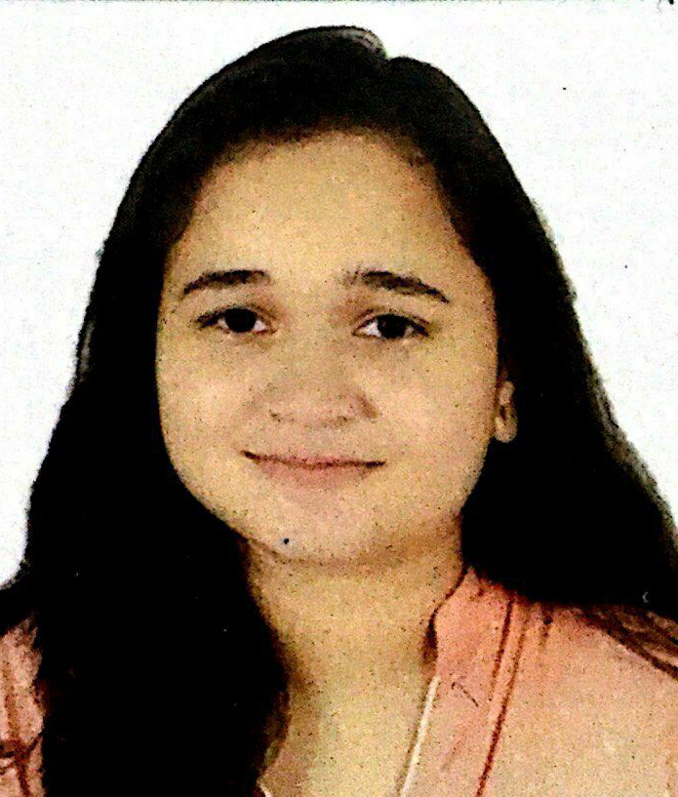

Academic Qualifications

COURSE | YEAR | INSTITUTION | UNIVERSITY/BOARD | PERCENTAGE
Pursuing M.A  (Psychology) | 2020-22 | The Indira Gandhi  National Open University (IGNOU) | IGNOU | -
B.A.(Hons.)  Psychology | 2016-19 | Lady Shri Ram college for Women | Delhi University | 69.32
12th standard | 2015-16 | Delhi Public School,  Indore | Central Board of  Secondary Education | 96.2
10th standard | 2013-14 | Delhi Public School,  Indore | Central Board of  Secondary Education | 93.1

Co-curricular activities
- Represented college at various competitions in rangoli and Hindi debate.
- Had been an active member of various committees such as Hostel food committee, Hostel anti-discrimination committee, Hostel postal committee, Design team of the department of psychology, College decor team, Hindi debating society, Worked for Green Cup Décor of Delhi University.

Positions of Responsibility
- Design Team head of the Department of Psychology for the year 2017-18.
- Games committee convenor of the Residence Hall, LSR (2017-18)
- Recreational Committee convenor of the Residence Hall
- Vice sports captain in school 11th standard.

Awards/Prizes won
- Awarded scholarship by Delhi public school, Indore for securing second position in the Indore city in humanities stream.
- Awarded Shri Guru Dev Gupt all-rounder scholarship award in 2015 (11th standard)

- Presented a paper at National Paper presentation competition organized by Daulat Ram College. The paper was also selected for publishing in their Annual edited book of psychology.

- Represented college at the Annual DU Flower show in 2018 and 2019 and secured the third and first position respectively.
- Written a group paper titled, ‘Women Position in Politics and Armed Forces’
- Paper titled, ‘A peek into emerging adulthood: resilience, life satisfaction and self- esteem’ selected for Multi Modal Interactive Session at National Academy of Psychology (NAOP) conference, 2018.
- Represented college at Annual flower show of Delhi university and secured third and second position in rangoli making competition in 2017 and 2018 respectively.
- Represented college at Sri Guru Tegh Bahadur Khalsa College and secured the second second position in Rangoli competition (2017).
- Secured second position in Muhavare competition organised by the Department of Hindi in the year 2017.
- Letter of Appreciation awarded for volunteering in the Decor team for Tarang 2017.
- Awarded Letter of Appreciation for heading the Design Team of the Department of Psychology for the session 2017-18.
- Awarded Letter of Appreciation for volunteering in the college Decor team for the session 2017-18.

Sports
- Member of the National Sports Organisation of LSR
- Participated in the Annual cross-country run from 2016 to 2019.
- Volunteered for the Annual Dr. Bharat Ram Sports meet in 2018 and 2019.
- Had been active in sports during school years and won many medals and certificates for the same.
Internships
- Intern at Heal.expert private limited
- Counselling internship at Nidaan Institute of Rehabilitation Training and Inclusive School

DATE: 21.03.2022
Varsha Shinde.

