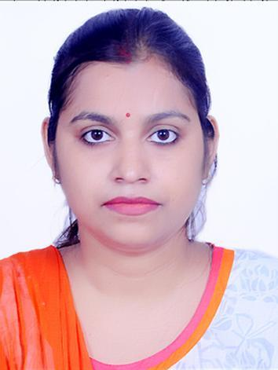
GUNJAN RATHORE

Phone: 9926485170, 9907040344
Email: 7rathoregunjan@gmail.com

ACADEMIC QUALIFICATIONS
S.No. | Degree | Subjects\Specialization | University/Board, City | %/SGPA | Year of Passing
1. | M.E | Industrial Systems and Drives | RGPV, Bhopal | 7.94 | 2016
2. | B.Tech | Electricals and Electronics | APJAKTU, Lucknow | 74.5% | 2012
3. | 12th | Physics, Chemistry, Mathematics, English, Physical Education | SRGMS, Agra | 84.5% | 2008
4. | 10th | Science, Social Science, English, Mathematics, Hindi | SRGMS, Agra | 77.7% | 2006

TEACHING EXPERIENCE
- As Assistant professor in Electrical Engineering Department, MITS College, Gwalior from 2019 to 2020.

ACHIEVEMENTS
- Participated in the “INTERNATIONAL WEB CONFERENCE ON RECENT ADVANCES IN NANOSCIENCE AND NANOTECHNOLOGY FOR HIGH END APPLICATIONS” organized by the department of APPLIED SCIENCE AND HUMANITIES, ASSAM UNIVERSITY,SILCHAR on 25th-26th JULY 2020.
- Participated in the webinar on “RECENT TRENDS IN ROBOTICS” organized by the department of MECH, RAO BAHADUR Y.MAHABALESHWARAPPA ENGINEERING COLLEGE, BALLARI, ON 20th AUGUST 2020.
- Participated in the webinar on “AI WITH MACHINE LEARNING '' organized by the department of computer science and engineering, S M K FOMRA INSTITUTE OF TECHNOLOGY,CHENNAI, on 18th JULY 2020.
- Attended Short Term Training Programme on “RECENT ADVANCES IN ELECTRICAL ENGINEERING”, organized by the department of Electrical Engineering, MITS College, from 1st-5th March, 2016.
- Attended National Workshop on “APPLICATIONS OF MATLAB IN ELECTRICAL ENGINEERING”, organized by the department of Electrical Engineering, MITS College, from 14th-15th Oct, 2015.
- Attended Short Term Training Programme on “SIMULATION TECHNIQUES OF POWER ELECTRONICS CONTROLLERS”, organized by the department of Electrical Engineering, MITS College, from 12th-16th May, 2015.
- Attended National Workshop on “SOFTWARE TOOLS FOR INDUSTRIAL DRIVES AND INSTRUMENTATION”, organized by the department of Electrical Engineering, MITS College, on 24th March, 2015.

INDUSTRIAL TRAINING

- SIEMENS Pvt. Ltd., Gurgaon.
- CROMPTON GREAVES, Malanpur.

PAPER PRESENTED

- "WIND POWER PREDICTION AND FORECASTING FOR THE GWALIOR REGION USING PSO ALGORITHM" in the 6th International Conference organized by IFEPR-India in association with “TRADA”.
- “WIRELESS POWER TRANSMISSION Via SOLAR POWER SATELLITE”, in the 2nd National Conference on ‘Innovations in Electrical Engineering (IIEE-15)’, organized by the department of electrical engineering during 10th-11th Feb, 2015.
- “WIND POWER PREDICTION AND FORECASTING FOR THE GWALIOR REGION USING MATLAB OPTIMISATION TOOL”, in 6th International Conference on ‘Technology Innovation and management for sustainable development’, held on 11th-13th Feb, 2015.

KEY SKILLS
- Excellent teaching skills.
- Skilled in collecting appropriate material for students.
- Very interested in educating college students.
- Motivate the students for learning.
- Excellent knowledge of subject areas and ability to teach students by using various methods.
- Expertise in advising the students and problem solving.
- Exceptionally good in the educational development of each student.

PERSONALITY TRAITS
- Excellent communication and comprehension skills.
- Positive attitude and goal oriented.
- Excellent advisory and problem solving skills.
- Strong interpersonal and organizational skills.
- Excellent verbal and written skills.
- Excellent leadership and team player

COMPUTER SKILLS
- C LANGUAGE
- MATLAB
PERSONAL DETAILS
- DOB: 18/06/1990
- CATG: OBC
- Marital Status: Married
- Languages known: Hindi and English
- Sex: Female
- Add: C 20 Govindpuri City Center Gwalior, MP.

