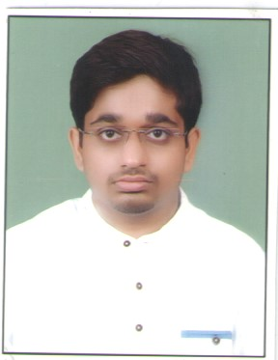  Anjaney Abhishek Tiwari  Contact Information:  Address:  c/o madhav Prasad shrivastava house dera pahadi school dera pahadi panna naka  City: chhatarpur  State: MP  Mb No. – 8959475476  Email Id:- anjabhi.24@gmail.com  Permanent Address:  C/o Shri Narendra Prasad tiwari old shiv mandir patpar ghat gram post teoni mangwana  City: rewa  State: MP  Mb No. -8871189431  Personal Data:  DOB : 24/02/91  Sex : Male  Nationality : Indian  Marital Status: Unmarried  Languages Known:  English, Hindi  Hobbies:  Playing Badminton, And Cricket and Chess .Surfing Net.  Listening to music and Reading book  Location  Indore, chhatarpur, rewa satna | CURRICULUM VITAE  Objective  Seeking a position to utilize my skills and abilities in the Education Industry that offers professional growth while being resourceful and innovative.  Academic Record  - Bachelor Of Engineering(Electronics And Communication)  Vitm, Indore 74% (aggregate)  - H.S.S (12th)  Gov. ex. School Deosar (Singrouli) 72.4%  - High School(10Th)  Gov. ex. School Deosar (Singrouli) 79.4%  Skills  Leadership skills, Team building skills, Writting Skill  Experience  S.no. Company Designation Duration  1. Career power, Indore branch Banking faculty 6 month  2. Pinnacle career institute Chhatarpur branch Reasoning Banking Faculty (Assistant branch manager) 1 year  3. Drishti IAS academy Chhatarpur Reasoning, computer faculty 4 month  4. Progressive career institute Reasoning, computer faculty 6 month  5. Knowledge Villa Chhatarpur HOD(ssc & banking Exam) Faculty (Computer/English) 2 year  6. Vedang academy, chhatarpur English faculty 1 year & continue  Special  - Specially designed notes for competitive Exam (specially Banking)  Subject:- Reasoning, banking, computer, advance math  - 3 times shortlisted for Bank interview.  Declaration  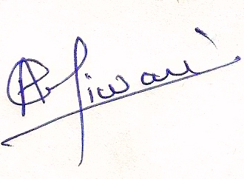  I confirm that the information provided by me is true to the best of my knowledge and belief.  Place : Rewa _____________________  Date : Signature

