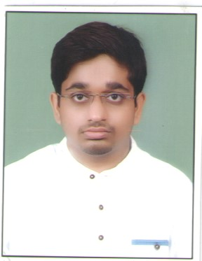  Anjaney Abhishek Tiwari  Contact Information:  Address:  c/o madhav Prasad shrivastava house derapahadi school derapahadi panna naka  City:chhatarpur  State:MP  Mb No. –9644374519  Email Id:- anjabhi.24@gmail.com  Permanent Address:  C/o Shri Narendra Prasad tiwari old shiv mandirpatparghat gram post teonimangwana  City:rewa  State:MP  Mb No. -8871189431  Personal Data:  DOB : 24/02/91  Sex : Male  Nationality : Indian  Marital Status: Unmarried  Languages Known:  English, Hindi  Hobbies:  Playing Badminton, And Cricket and Chess .Surfing Net.  Listening to music and Reading book  Location  Any where in India | CURRICULUM VITAE  Objective  Seeking a position to utilize my skills and abilities in the Education Industry that offers professional growth while being resourceful and innovative.  Academic Record  - Bachelor Of Engineering(Electronics And Communication)  Vitm, Indore 74% (aggregate)  - H.S.S (12th)  Gov. ex. School Deosar 72.4%  - High School(10Th)  Gov. ex. School Deosar 79.4%  - PGDCA 64%  Skills  Leadership skills, Team building skills, Communication Skill  Experience  S.no. Company Designation Duration  1 Pinnacle career institute Chhatarpur branch Reasoning Faculty & Assistant branch manager 1 year  2. Knowledge Villa Chhatarpur Reasoning Faculty & Assistant branch manager 3 year  3. Vedang academy chhatarpur Faculty English subject 1 year  4. Kaivalya IAS Institute Faculty Computer Currently working Since 23 Nov 2019  Special  - IBPS Mains Out 2015  - IBPS Clerk Mains out 2016  - Interview out IBPS RRB 2017  - IBPS RRB Clerk Out 2018  - SSC CGL Tier 2 Out 2018  - LIC Assistant Mains Out 2019  Declaration  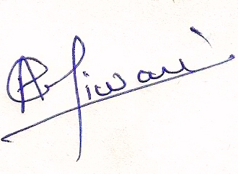  I confirm that the information provided by me is true to the best of my knowledge and belief.  Place :Chhatarpur_____________________  Date : 20 January 2020 Signature

