Resume 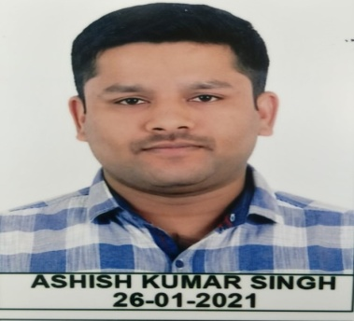
Name- Ashish kumar singh
Father’s Name –kalyan singh
Dob- 22/08/1994
Gender –male
Contact No-8516873655
9424323252
Email ID- gaharwarashish22@gmail.com
Communicatin skills-hindi ,English
Objective-seekingh opportunity to use my knowledge and talent to educate for public admistrator of future.

Professional efficiency-
- A passion about teaching felid with a great teaching aptitude.
- Thorough knowledge of the subjects to be taught and its backgroubd .
- Effective classroome manangemant.

Educatinal qualification-
Exam passed | cource | University/school | Year | % marks
Graduation | BSc(geology) | B U Bhopal | 2015 | 67.8%
12th | PCM | MP board | 2012 | 82%
10th | All aproriate subjects | MP board | 2010 | 90.5%
PGDCA | PG | MCN Uneversity bhopal | 2017 | 70.4%
Other achivments-
- C certificate in national social service(NSS)
- Apair in MPPSC mains of 2017 ,2018,and also 2019
- Have 160 marks in MPPSC pre 2019 also
Declaration-
I hereby declare that all the details fumished above are true to the best of my knowledge .

Date…… signature

