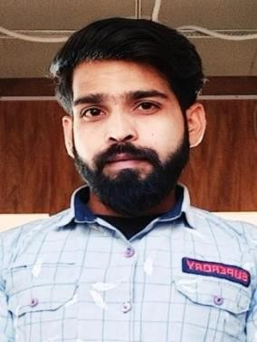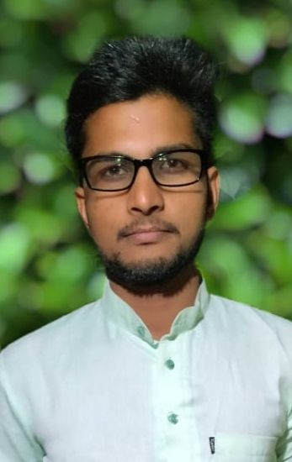

Deendayal Jatav

Gmail:- dindayal154@gmail.com Mob.No:-7879709544,7987429048
Add : Village Nariyabey Post Barkheda Block Biaora District RAJGARH MP 465674

Objective

To deliver the results with consistency putting all the efforts with commitment and passion towards the Growth of organization.

Personal Profile
- Name: Deendayal jatav
- Mobile no: 7879709544,7987429048
- Date of Birth: 06/07/1994
- Father’s name: Mr. Khushilal jatav
- Languages known: Hindi, English
- Strength: Dedicated to work, Honest
- Permanent Address: Village Nariyabey Post Barkheda Block Biaora District Rajgarh
(M.P)

Relevant Work Experience
1.

- 1 Year Teaching Experience as a (teacher & Director) at Eklavya Institute Rajgarh
- 6 Month Teaching Experience as a faculty at Sankalp IAS Academy Shujalpur

Education
- 10 th completed from mp board bhopal with 47.2% in 2013
- 12 th completed from mp board bhopal with 65% in 2015
- B A Completed from BU Bhopal with 60% in 2018
- MA. Completed from BU Bhopal with 60% in 2020
- DCA Completed from MCU bhopal with 68% in 2016

Diclaration

I hereby declare that the above information is complete and correct tothe best of my knowledge.
T

Date
DEENDAYAL JATAV

