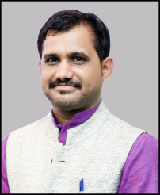
RESUME
Dinesh Mathankar
Contact details: 9584333054, 7974977312
Email address: dineshmathankar87@gmail.com

Career Objective
- Seeking the position of a Teacher in an organization that will give me an opportunity to pass on my knowledge to the students in a innovative manner.
Profile
- 5 Years of experience as a Hindi & Pedagogy Teacher
- Currently working in Goutam IAS Academy Wright Town Jabalpur (M.P.)
- Excellent Communication Skill.
- Qualified CTET GRADE 1 & 2.
Skills
- Profound knowledge of Hindi Language and ability to teach the language for all sort of students i.e. those who have Hindi as their first language and those who have not.
- Technical Awareness of using Pen-tablets , Smart Board and Youlube Live through OBS.
- Using self creativity for a better result in this field.
- Making use of innovationg techniques for attaining the academic and teaching goals of the organization.
Qualification details
- M.A. (Hindi Literature) from “B.U.” with 62.82 % in 2017.
- B.Ed. from “B. U.” with 73.62% in 2015.
- B.A. from “B.U.” with 68% in 2011.
- 12th from M.P. Board with 64%.
- 10th from M.P. Board with 60%.
Personal details
Name: Dinesh Mathankar
Father’s Name: Mr. Sahebrao Mathankar
D.O.B.: 12/05/1987
Gender: Male
Marital Status - Married
Nationality: Indian
Languages: Hindi, English & Marathi.

DECLARATION
I hereby confirm that the information given above is true to the best of my knowledge and belief.

Date: Dinesh Mathankar
Place:

