RESUME

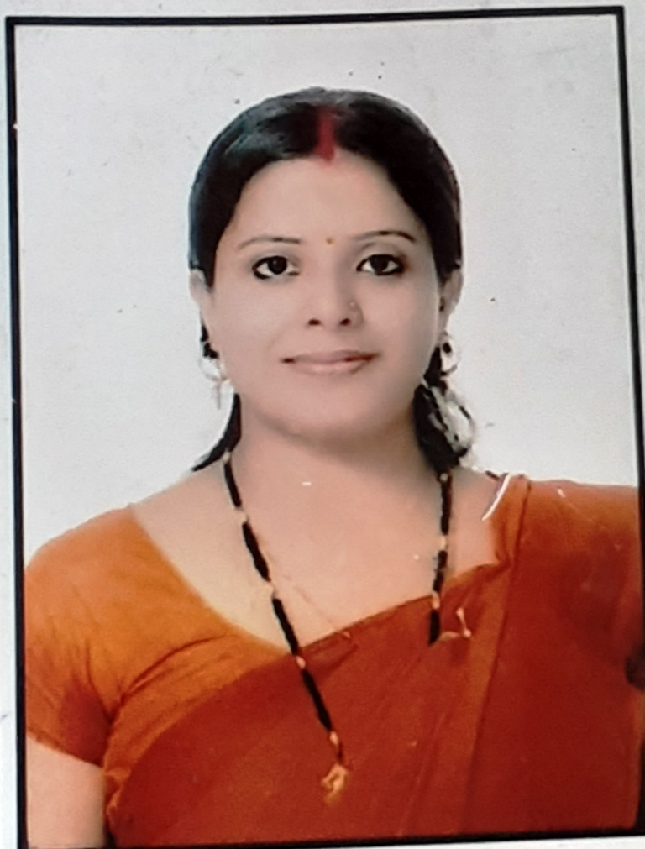
Abhilasha Kashyap
Plot Number 39, Jai Bheem Nagar, Gwarighat Road,
Jabalpur
Email Address: abhi.manish27@gmail.com
Contact number: 7999789931
---------------------------------------------------------------------------------------------------------------------
CAREER OBJECTIVE: To apply my expertise in English language and literature for enhancing the linguistic skills of students and to innovate methods of teaching of the same for making the learning of English language easy and interesting for non-native learners.
EXPERIENCE:
I possess valuable teaching experience of nearly 8 years working in Gyan Ganga Institute of Technology and Sciences, Jabalpur since 2012.

EDUCATIONAL QUALIFICATION:
- Ph.D. in English R.D.V.V Jabalpur in 2020.
- M. Phil in English from R. D. V. V, Jabalpur in 2013 with 1st division.
- M.A in English Literature from Mata Gujri College Jabalpur in 2010 with 1st Division.
- B.A. from Govt. Autonomous M. K. B. Arts & Commerce College for Women, Jabalpur in 2008 with 2nd Division.
- 12th from M.P Board Bhopal with 1st division
- 10TH from M.P Board, Bhopal with 1st division.

ADDITIONAL QUALIFICATIONS/ACHIEVEMENTS:
- Registered in code 28 of RDVV as an Assistant Professor for the college of Gyan Ganga College of Excellence ( one of the branches of Gyan Ganga Engineering college)

- Diploma in Fashion Designing from Govt. Women’s Polytechnic College, Jabalpur in 2008.
- P. G. D. C. A. From M. C. R. P. V, Bhopal in 2011 with 1st division.

LANGUAGES KNOWN:
Hindi & English
HOBBIES:
Drawing, Music, Reading Books.
WORKSHOPS/ SEMINARS/CONFERENCE:
- Participated in National Level Seminar on “Changing Trends in New Indian Poetry In English”.
- Participated in the workshop on” Professional Development” organized by Department of U.G, P.G & Research in English and’ English Language Teachers’ Association of India (ELTAI).
- Participated in a “National Workshop on Selection of titles for Research in English” organized by Department of P.G. Studies & Research in English, RDVV, Jabalpur.
- Participated in the National seminar on New English Literature of the Decolonized organized by the Department of PG. Studies in English, Hawabagh Women’s College Jabalpur.
- Presented a research paper titled “Empowerment of Women in The God of Small Things by Arundhati Roy: A writer of Decolonized country.”
- Published abstract on: “Empowerment of Women in The God of Small Things by Arundhati Roy: A writer of Decolonized country.” in the National seminar on New English Literature of the Decolonized
- Published the research paper titled “Empowerment of Women in The God of Small Things by Arundhati Roy: A writer of Decolonized country.”
- Published the research paper in Social Research Foundation titled ‘ Empowerment of women: The Scarlet Letter’
- Published the research paper in Social Research Foundation titled ‘ Empowerment of women: The God of Small Things’

PERSONAL PROFILE:
Date of Birth : 27.06 .1986
Gender : Female
Marital Status : Married
Husband’s Name : Mr. Manish Raikwar
Nationality : Indian
DECLARATION:
I hereby declare that all the above information is true to my personal knowledge and belief.
Place : Jabalpur Signature
Date: Abhilasha Kashyap

