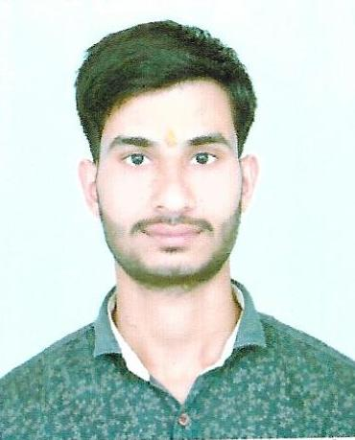 Mob. – 9074278470 ,9111845847
Keshri Yadav Email:- keshri.yadav95@gmail.com
Career Objective
I am looking for a job that will offer me opportunities to grow and achieve knowledge. I am sincere, loyal and smart working.
Academic Qualification
- Postgraduate Diploma in Computer Application (PGDCA)
- B.sc from Davv University Indore (M.P)
- Higher Secondary Certificate from M.P. Board Bhopal (M.P)
- High School Certificate from M.P. Board Bhopal
Working Experience
3 Year - CSC - VLE And Mp Online,
2 Year - HGS Conputer Operator,
2 Year - Ankuran Public School.
Computer Proficience
- Basic Technical computer knowledge,
- Hindi Typing 26-30 WPM and English Typing 35-40 WPM and I will according to improve current working experience.
Personal Interests
- Watching and Playing Cricket ,
- Reading and writing.
Personal Details
Father’s Name : Tulsiram Yadav
Birthday : November 12, 1995
Gender : Male Marital Status : Single
Declaration
I Keshri Yadav hereby declare that the information contained herein is true and correct to the best of my knowledge and belief.
Keshri Yadav

