CURRICULUM VITAE
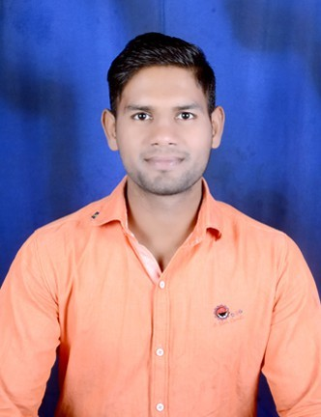
KUNAL MALAKAR

OBJECTIVE:
To pursue a challenging career in physical education that utilizes my skill to the highest degree and provide me an opportunity to learn perpetually and to live a life that matters.
SPECIALIZATION: KHO-KHO, TRACK&FIELD AND VOLLEYBALL

EDUCATIONAL QUALIFICATIONS:

Qualification/degree | College/institution | Year of Passing
M.P.ED | School of physical education ( d.a.v.v) Indore | 2015
B.P.E | School of physical education ( d.a.v.v) Indore | 2013
HSC (M.P BOARD) | B.H.S.S. Maheshwar | 2010
SSC (M.P.BOARD) | B.H.S.S. Maheshwar | 2008

EXPERIENCE:
- Currently working with Taiyebi Eng. Med. Hr. Sec. Ujjain since last 6 years.
- Worked with The Sports Gurukul in First Step School Chhindwara
- Worked at Gym as a Fitness Instructor
- As an Official to conduct 26th Kayaking & Canoeing National Championship
- As an Official to conduct International Athletic Meet
- As an Official to conduct Kho-Kho Cluster
- As an Official to conduct Volleyball cluster

KNOWN LANGUAGES:
HINDI, ENGLISH

ACHIVMENTS:
- Participated in 52th State level KHO-KHO Competition Organized by M.P. Sports committee Got 3rd place 2006.
- Participated in University team Volleyball Competition held at Jaipur 2010-11
- Participated in University team Volleyball Competition held at Cari 2012-13
- Participated in University team Volleyball Competition held at Udaipur 2014-15
- Participated in University team Kho-Kho Competition held at Nander 2011-12
- Participated in University team Kho-Kho Competition held at Orisa 2013-14
- Participated in University team Kho-Kho Competition held at Udaipur 2014-15
- Participated in Inter College Athletics Competition held at Dhar 2011-12 Got 2nd place
- Participated in Inter College Athletics Competition held at Dhar 2011-12 Got 3nd place
- Participated in Inter College Handball Competition held at Indore 2012-13 Got 2nd place
- Participated in Inter College Badminton Competition held at Indore 2012-13 Got 2nd place

COMPUTER FAMILIARIZATION:
STRENGTHS:
Basic working knowledge of Microsoft office, Windows operating system and software such as Inter net email etc.
Honesty, hardworking, disciplined, willingness to take challenges, leadership qualities, adaptability, willingness to learn, decision making skills, self-motivated etc.

CO CURRICUALR ACTIVITIES:
- Participated in inter house competitions like handball, kho-kho, , TUG OF WAR.

HOBBIES:
- Listening music, Playing games.

PERSONAL INFORMATION:
Communication address : KUNAL MALAKAR
Nageshwar marg mali MohalLa maheshwar Dist. Khargone (M.P.)
Email Id : kunalmalakar0391@gmail.com
Contact no. : 9516834821
Gender : Male
Date of birth : 24 March 1991
Marital status : single
Nationality : Indian
DECLARATION: I, KUNAL MALAKAR, hereby declare that all the above information is true to the best of my knowledge.

Place: MAHESHWAR KUNAL MALAKAR DATE:

