Mahendra kumar Mishra

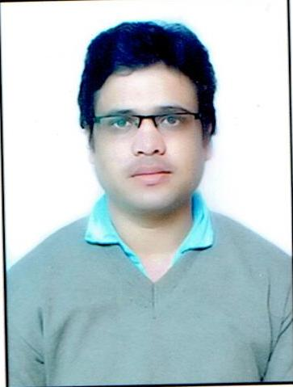
Mob. No. 6260588984
7089371400
Email: - mhndramishra11111@gmail.com

CARRIER OBJECTIVE

Willing to work in an organization, where I can use my skills for the growth of both myself and the organization.

ACADEMICS

Year | Degree |  | Institution/ Board | % Marks
2008-2012 | Bachelor of Engineering Electrical & Electronics  Engineering |  | NRI Institute of Information Science & Technology  (Rajiv Gandhi technical University, Bhopal) | 75.59
2008 |  | 12 | MP BOARD  ( govt excellence school no one chhatarpur mp) | 64.50
2006 |  | 10 | MP BOARD  ( govt excellence school no one chhatarpur mp) | 81.80

TECHNICAL SKILLS
- Network analysis
2 Control system
3 electrical Power System
4 electrical machine

PROJECTS UNDERTAKEN
Minor Project: TRAFFIC LIGHT CONTROLLER
Traffic light controller is used for traffic controlling thus helping in proper traffic management and also preventing accidents.

Major project:wireless energy meter

Wireless energy meter is one simple idea to taking the readings wirelessly we open up the avenues for various benefits one is the reduction of expenditure, second is the reduction of manpower, thirdly and most importantly is the curbing in this field.

TRAINING

- Minor training:-MPVV Pvt. Ltd. BHOPAL(MP)
- Major training:- SOFCON India pvt. Ltd. Bhopal

EXPERIENCES

Working as an assistant professor in EE department inPeoples University from 13 march 2013 to 25 march 2014

ACHIEVEMENTS / EXTRA CURRICULAR ACTIVITIES

- Workshop on PLC & SCADA (by-SOFCON India Pvt. Ltd.)
- Work shop on Energy meter testing & maintenance( by cpri bhopal)

STRENGTHS

  - Good training skills.
  - Work effectively with diverse group of people.
  - Fast learner, adapt well to changes and pressure in workplace.

PERSONAL DETAILS

- Father’s NAME : Mr Ram Kripal Mishra
- Date of Birth : 04/07/1989
- Nationality : Indian
- Languages Known : English, Hindi
- Marital Status : Single
- Hobbies :Gardening
- Contact Address : 100 MOURAHA, POST GATHEWRA,Distt.-CHHATARPUR (MP)(PIN-471001)
- Contact No. : +91-7089371400, 6260588984

DECLARATION

I hereby declare that the above information furnished by me is true to the best of my knowledge and given an opportunity, I shall definitely prove my worth.
Date:
Place: Bhopal (MAHENDRA kumar MISHRA)

