CURICULLUM VITAE  MAYANK JAIN  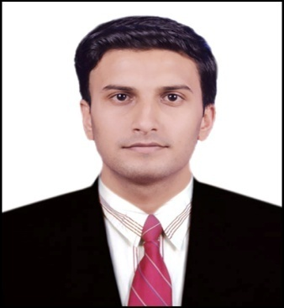  CONTACT ADDRESS  H.No33 Shivram Complex Beside Noble College Makronia Sagar, M.P.  C/o M.  MOBILE NUMBER  7999507821  E-MAIL  Mayankj54@gmail.com  PERSONAL DETAILS  Father’s Name:  Mr. S.C.Jain  DOB: 16th-Dec-1991  Gender: Male  Nationality: Indian  Languages Known:  English and Hindi.  MaritalStatus: Single . | CAREER OBJECTIVE  To work in a challenging environment where I can proof myself.  ● To gain an entry level position in the organization & to grow with the organization. I can contribute proficiently for my employer and where my experience, education, skills and abilities will be an asset.  ● Work as a team player and improve my inter personal Skills & leadership qualities.  ACADEMIC PROFILE  2013: Bachelor of Engineering (Mechanical ) from SRIT Jabalpur,  ( Marks Percentage : 71% )  2009: 12th – Govt.Higher Secondary School Bansagar MP BOARD  ( Marks Percentage : 82 % )  2007: 10th – Saraswati Shishu Mandir Bansagar M.P. BOARD  ( Marks Percentage : 85 % )  CERTIFICATES  - Designing Certificate In CATIA V5 from All India IT Association Delhi .

EXPERIENCE
- 04 yrs experience as home tutor upto 12th class.
- 02 times mains written exam exp. in MPPSC.
- Qualified in vyapam Patwari exam 2017

AREA OF INTEREST
- Maths , Physics ,Science and Designing

JOB SKILLS
- Ability to work both individually as well as in a team.
- Dedicated and consistent towards my work.
- Time management.

SOFT SKILLS

- Self confident to achieve goals.
- Self motivated, Hard worker.
- Very much eager to learn new things.

HOBBIES

- Collecting of information about new things
- Reading books and news papers
- Travelling, Net Surfing

DECLARATION

I hereby declare that all the information and facts given above are true
to best of my knowledge and belief.

Place: Sagar MAYANK JAIN
Date : 30-03-2018

