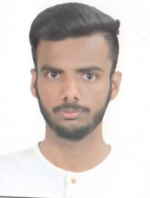
Parth Paliwal
33 , prime park , behind queens college
Limbodi ,Indore, Madhya Pradesh. PINCODE-452001
 +91 7509650651
paliwalparth999@gmail.com

CAREER OBJECTIVE:
Develop and promote creativity and high-order thinking skills that increase the performance of the students.

EDUCATIONALCREDENTIALS:
Bachelor of Engineering –Mechanical Engineering 2013 - 2017
MIT, Indore affiliated to RGPV with 7.87 CGPA.

Board of Higher Secondary Education – Maths, Physics & Chemistry 2012 - 2013
Madhya Pradesh Board with 82 %

Board of Secondary Education 2010 - 2011
Madhya Pradesh Board with 82%

INTERNSHIP:
Organization : National fertiliser limited (NFL) , vijaipur (M. P.)
Duration : 15 days

Orgnization : PATH India Ltd. Mhow
Duration : 15 days
PROJECT DESCRIPTION:
MINOR PROJECT:
Organization : MIT Indore (M.P)
Description : Study & Analysis of “Compressed Air Powered Bicycle”
Duration : 6 months
Role : As a team member, worked on the “Compressed Air Powered Bicycle”

MAJOR PROJECT:
Organization : MIT Indore (M.P)
Description : Study & Analysis of “ Paper Cutting Machine ”
Duration : 6 months
Role : As a team member, worked on the “Paper Cutting Machine”

TECHNICAL SKILLS: Basic knowledge of computer , solid work.

PERSONAL VITAE:
Date of Birth: 09/02/1996
Marital Status: Unmarried
Father’s Name : Mr. Satish Kumar Paliwal
Mother’s Name: Mrs. Suchita Paliwal
Languages Known: English & Hindi

DECLARATION
I hereby declare that all the information provided by me in this application is factual and correct to the best of my knowledge and belief
Date :
Place : Parth Paliwal

