CURRICULUM VITAE
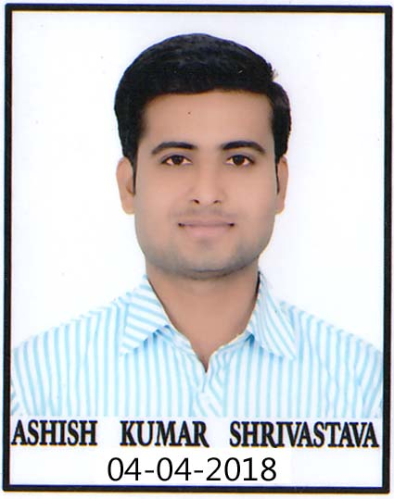
Ashish Kumar Shrivastava

Cell : 7987096035, 8871174031
Email : ashishshrivastava983@gmail.com

CAREER OBJECTIVE :

To work in a firm with a professional work driven environment where I can utilize and apply my knowl- edge, skills which would enable me as a fresh graduate to grow while fulfilling organizational goals.
ACADMICS :

Qualification | School/College | Board/University | Duration
B.com ( Computers ) | Vrinda Sahay P.G. College,Dabra | Jiwaji University Gwalior | 2013
M.com ( Management ) | Vrinda Sahay P.G. College,Dabra | Jiwaji University Gwalior | 2016
L.L.B. | Gwalior Law College,Gwalior | Jiwaji University Gwalior | 2019
D.el.ed | ---- | N.I.O.S. | 2019
Experience :-

- Experience :
(Total Experience – 8 Years)

- Swarna Plastic Industries, As a Accountant and Manager 7 Years.

- Administration head and Accountant in Balaji Public School, 1 Year.

- Administration head and Accountant in IPS(Adarsh) H.S. School, 1 Year.

Computer Skills : -

- PGDCA from MCRPV Bhopal.
- Good Command in MS-Office.
- Good Command in Accounting Software.
PERSONAL DETAILS:
- Father’s name : Mr. S. B. Shrivastava
- Date of Birth : 08/04/1993
- Language proficiency : English, Hindi
- Nationality/Religion : Indian
- Marital status : Unmarried
- Hobby : Writing and Reading

Sign.

Ashish Kumar Shrivastava

