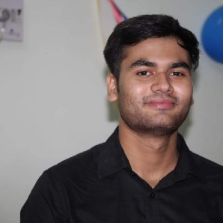
SUSHANT AGNIHOTRI
Behind shiv mandir, Anand nagar, Rewa
7000607729 shushantagnihotri1@gmail.com

EXPERIENCE
Unacademy
08/03/2020
-
08/06/2020
Campus leader
Creating awareness about online courses and getting students to subscribe to plus courses
Local coaching institutions -
Translator
Translator and content creator

EDUCATION
Thakur ranmant singh college of excellence
B. A. (Hon.) English literature
70%
2020

INTERESTS
Education
Translation

PERSONAL STRENGTHS

Hard working, Going an extra inch after being exhausted

PERSONAL PROFILE
Date of Birth
:
03/07/1998
Marital Status
:
Single
Nationality
:
Indian
Known Languages
:
English, Hindi, Bagheli
Hobby
:
Reading Writing Travel
Passport
:
Indian

DECLARATION

I hereby declare that all the above information provided by me is true and if anything found to be false only i shall be responsible
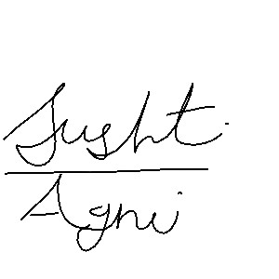
SUSHANT AGNIHOTRI

