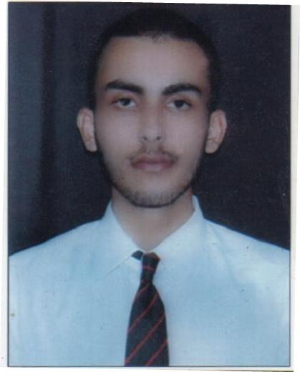
RESUME
ISHAN SARAIYA
Contact Information -
Mobile No.: 7987142969
Current Location:112/B1 rameshwaram colony vijaynagar
Jabalpur (M.P.)
Email Id- ishansariya03@gmail.com
Career Objective-
To work for an organization which provides me the opportunity to improve my skills and knowledge to growth along with the organization objective
Technical skill -
- Languages - C, C+ +
- Operating System- Microsoft & DOS
- Database - DBMS, Microsoft access , SQL, Ms Office
Other Skill:-
- Very good logical and analytical skill.
- Excellent in internship and Decision Making Ability.
- Leadership Quality
Professional & Educational Detail
Course | Subject | University /Board
10th | All Subject | Central Board of Secondary Education
12th | PCM | Central Board of Secondary Education
B.Sc. | Computer science | St. Aloysious College Jabalpur

Work Experience -

- Teaching in Coaching Classes.

Personal Information-

Name – ISHAN SARAIYA
Father’s Name –Shri Manoj Saraiya
Mother’s Name – Smt. Anita Saraiya
Date of Birth – 03/11/1996
Language Skill – Hindi,English
Nationality – Indian

About me –
- I am a very hard working and enthusiastic person.
- I always believe in positive thinking.

Hobbies & Interest:
- Teaching
- Tracking

Place – Jabalpur Signature
Date – 29/12/2018

