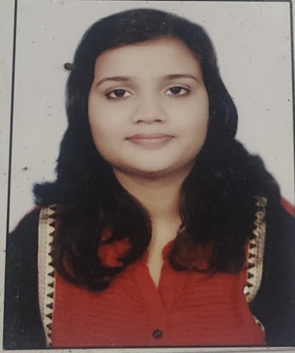
TANU MISHRA.
Contact:9302522029
E-mail I’d- tanu59860@gmail.com
Address-3492k/m milk skeem road Adhartal, Jabalpur,M.P.

Objective
To frame a carrier that allows me to be compatible in any competitive environment and also boost up my capacities, knowledge and energy to their positive full and a drive for self improvement with sincerity, dedication and smart work.

Personal profile
Name -. Tanu Mishra
Date of birth -. 14 June 1996
Father’s name. -. Kailash Nath Mishra
Mother’s name -. Jyoti Mishra
Nationality. -. Indian
Language. -. English, Hindi.
Hobbies -. Cooking and listening to music.

Education
Bachelor of engineering in electronics and communication from Gyan Ganga college of technology Jabalpur in CGPA 7.47
Examination | College/school | University/board | Percentage
B.E 8th Semester | Gyan Ganga college of technology, jabalpur | RGPV | 8.31
B.E 7th semester | Gyan Ganga college of technology jabalpur | RGPV | 8.06
B.E 6th semester | Gyan Ganga college of technology jabalpur | RGPV | 8.06
B.E 5th semester | Gyan Ganga college of technology jabalpur | RGPV | 7.56
B.E 4th semester | Gyan Ganga college of technology jabalpur | RGPV | 7.13
B.E 3rd semester | Gyan Ganga college of technology jabalpur | RGPV | 7.06
B.E 2nd semester | Gyan Ganga college of technology jabalpur | RGPV | 6.33
B.E 1st semester | Gyan Ganga college of technology jabalpur | RGPV | 6.33
12th | Spring day higher secondary school jabalpur | MP BOARD | 67
10th | Spring day higher secondary school jabalpur | MP BOARD | 76

Projects
- Major project. : “SARCOS” wearbale exoskeleton
- Minor project. : Quality control and product fault detection using image processing.

AWARDS /ACHIEVEMENTS
- 1st rank in “srijan” Zonal level competition.
- 2nd rank in “srijan” State level competition.
- 1st rank in “Dream Jabalpur” Zonal level competition.
- 3rd rank in jigyasa state level interrcollege technical competition.
- 2nd rank in “Model Mania”.

TECHNICAL TRAINING
- Vocational training from MPPTCL Jabalpur.
- Industrial training in ROBOTICS MAESTRO from DRmz Tech.
- PCB designing.

EXTRA CURRICULAM
Volunteer in Food mania in tech fest Gyanotsav 2k15.

PARTICIPATING IN
- Srijan 2016(festival of techincal papers and innovative model) State level competition.
- Jigyasa 2015 State level techincal model competition.
STRENGTH
- Discipline
- Creativity
- Creative writing
- Good communication
- Planning execution

